Orchestrating Determinism in Generative Software Engineering: A Hierarchical Multi-Agent Framework for Schema-Guided Vibe Coding

By
Nouran Darwish

Supervised by
Dr. Mohammed Sabry

.
Cairo, Egypt
2026

Seminar Committee Page
The committee for
Nouran Hussien ElSaleh Moustafa Hassan Darwish
certifies that this is the approved version of the following thesis proposal, which was accepted for quality and form by the seminar committee:
Orchestrating Determinism in Generative Software Engineering: A Hierarchical Multi-Agent Framework for Schema-Guided Vibe Coding
Seminar Committee Members:
Committee Supervisor: [insert name]
Signature: ____________________________________________________
Date: ________________________________________________________
Committee Co-Supervisor (if appropriate): [insert name]
Signature: ____________________________________________________
Date: ________________________________________________________
Committee First Member: [insert name]
Signature: ____________________________________________________
Date: ________________________________________________________
Committee Second Member: [insert name]
Signature: ____________________________________________________
Date: ________________________________________________________
Committee Third Member (if appropriate): [insert name]
Signature: ____________________________________________________
Date: ________________________________________________________

Cairo University
2026

Abstract
Orchestrating Determinism in Generative Software Engineering: A Hierarchical Multi-Agent Framework for Schema-Guided Vibe Coding
by
Nouran Darwish
Master of Science in the Department of Data Science at the Faculty of Graduate Studies ‎for Statistical Research.
Cairo University, 2026

The emergence of "vibe coding"—software development through natural language prompts to large language models (LLMs)—has democratized programming by enabling non-experts to create functional applications. However, the inherent non-determinism of LLMs introduces unpredictability in output quality, feature completeness, and code structure, limiting vibe coding's applicability for production software. This thesis addresses the fundamental question: Can structured multi-agent orchestration achieve deterministic, high-quality software generation while preserving the accessibility of natural language prompting?
This research proposes the Pentagon Protocol, a hierarchical multi-agent framework consisting of five specialized agents—Product Owner, System Architect, Backend Engineer, Frontend Engineer, and QA Engineer—that mirrors established software development team structures. The framework introduces Schema-Guided Vibe Coding, a paradigm that applies Pydantic-based schema constraints at each generation phase, progressively reducing output entropy from ambiguous natural language prompts to validated, structured code artifacts.
The Pentagon Protocol was evaluated against a single-agent Baseline across the VibePrompts-10 dataset, comprising 10 prompts spanning easy, medium, and complex application scenarios with 78 total expected features. Both approaches utilized DeepSeek V3.2 with deterministic settings (temperature 0.0). Evaluation encompassed six dimensions: feature completeness, pipeline success, code executability, QA pass rate, code quality, and execution efficiency.
Experimental results demonstrate that the Pentagon Protocol significantly outperforms the Baseline approach. Pentagon achieved 97.8% feature implementation versus Baseline's 92.5% (+5.3%), with advantages increasing for complex prompts (+8.7%). Code quality improved by 44% (70.8% vs 49.2%), with the largest gains in error handling (+74%) and API design (+50%). Pentagon exhibited 30.6% lower variance in composite scores, demonstrating more consistent output quality. Pentagon won 100% of composite score comparisons (10/10 prompts), validating the effectiveness of schema-guided multi-agent orchestration.
The trade-off analysis revealed that Pentagon requires approximately 5× more execution time (255s vs 50s) but delivers measurably higher quality outputs that reduce downstream maintenance and debugging costs. The QA phase achieved 100% test pass rate across all prompts while generating actionable improvement recommendations.
This thesis makes three primary contributions: (1) the theoretical formalization of Schema-Guided Vibe Coding as a paradigm bridging informal prompting and rigorous software engineering; (2) the Pentagon Protocol architecture with reusable agent definitions, schema specifications, and orchestration patterns; and (3) empirical evidence quantifying the advantages of multi-agent orchestration across multiple quality dimensions.
The findings support the central thesis argument that hierarchical multi-agent orchestration with schema constraints successfully "orchestrates determinism" in generative software engineering. The Pentagon Protocol offers a practical approach for achieving reliable, high-quality AI-assisted software development while maintaining the accessibility that makes vibe coding appealing. Future research directions include multi-model orchestration, adaptive phase configurations, and integration of human-in-the-loop feedback mechanisms.

Table of Contents
Seminar Committee Page ii
Abstract iii
Table of Contents v
Chapter 1: Introduction 1
1.1 Overview and Background 1
1.1.1 The Software 3.0 Paradigm 1
1.1.2 The Rise of Multi-Agent Systems 2
1.2 Motivation 2
1.2.1 The Accessibility-Quality Tradeoff 2
1.2.2 Industry Response: Spec-Driven Development 3
1.2.3 The Gap: Schema-Guided Multi-Agent Orchestration 4
1.3 Problem Statement 5
1.3.1 The Core Challenge 5
1.3.2 Research Question 5
1.3.3 Sub-Questions 5
1.4 Research Objectives 5
1.4.1 Theoretical Contribution 6
1.4.2 Architectural Design 6
1.4.3 Implementation 6
1.4.4 Empirical Validation 6
1.5 Significance of the Study 7
1.5.1 Theoretical Significance 7
1.5.2 Practical Significance 7
1.5.3 Industry Relevance 7
1.6 Scope and Limitations 7
1.6.1 Scope 7
1.6.2 Limitations 8
Chapter 2: Literature Review 9
2.1 Introduction 9
2.2 Vibe Coding and AI-Assisted Development 9
2.2.1 Origins and Definition 9
2.2.2 Evolution Through 2025 9
2.2.3 Critical Perspectives 10
2.2.4 Spec-Driven Development as Evolution 11
2.3 Multi-Agent Frameworks for Software Engineering 11
2.3.1 Foundational Work 11
2.3.2 Empirical Evidence for Multi-Agent Superiority 12
2.3.3 Architectural Patterns 12
2.4 Determinism in AI Systems 13
2.4.1 Sources of Non-Determinism 13
2.4.2 Determinism Strategies 13
2.4.3 Determinism and Multi-Agent Systems 14
2.5 Schema-Guided Generation 14
2.5.1 Structured Output Formats 14
2.5.2 Pydantic for LLM Validation 15
2.5.3 Schema-Guided Code Generation 15
2.6 Gap Analysis 16
2.6.1 Summary of Existing Approaches 16
2.6.2 Identified Gaps 16
2.6.3 Research Contribution 17
2.7 Theoretical Foundation 17
2.7.1 Information-Theoretic Perspective 17
2.7.2 Software Engineering Perspective 18
2.8 Chapter Summary 18
Chapter 3: Framework for the study 19
3.1 Introduction 19
3.2 Theoretical Model: Schema-Guided Vibe Coding 19
3.2.1 Formal Definition 19
3.2.2 The Entropy Reduction Model 20
3.2.3 The Transformation Pipeline 20
3.2.4 Determinism Guarantees 21
3.3 Pentagon Protocol Architecture 22
3.3.1 Architecture Overview 22
3.3.2 Agent Specifications 24
3.3.3 Schema Definitions 26
3.4 Study Variables and Hypotheses 29
3.4.1 Independent Variables 29
3.4.2 Dependent Variables 29
3.4.3 Control Variables 30
3.4.4 Hypotheses 30
3.5 Experimental Design 31
3.5.1 Design Type 31
3.5.2 Experimental Procedure 31
3.5.3 Implementation Details 32
3.6 Data Collection and Analysis 33
3.6.1 Artifacts Collected 33
3.6.2 Completeness Scoring 33
3.6.3 Executability Testing 33
3.6.4 Requirement Alignment 33
3.6.5 Consistency Measurement 34
3.7 Evaluation Metrics Summary 34
3.8 Ethical Considerations 34
3.9 Limitations of the Framework 35
Chapter 4: Implementation 36
4.1 Introduction 36
4.2 Technology Stack 36
4.2.1 Technology Selection 36
4.2.2 System Requirements 36
4.3 System Architecture 37
4.3.1 Component Overview 37
4.3.2 Data Flow 37
4.4 Schema Design 38
4.4.1 Design Principles 38
4.4.2 Schema Overview 39
4.4.3 JSON Parsing Strategy 39
4.5 Agent Configuration 40
4.5.1 Determinism Configuration 40
4.5.2 Agent Specialization 40
4.6 Task Implementation 41
4.6.1 Task Structure 41
4.6.2 Prompt Engineering 41
4.7 Orchestration Implementation 42
4.7.1 Pipeline Execution 42
4.7.2 Output Management 42
4.8 Baseline Implementation 43
4.8.1 Single-Agent Approach 43
4.8.2 Baseline Limitations 43
Chapter 5: Results and Analysis 44
5.1 Experimental Overview 44
5.1.1 Experimental Setup 44
5.1.2 Dataset Composition 45
5.1.3 Evaluation Dimensions 46
5.2 Expected Features Implementation 46
5.2.1 Overall Feature Implementation Results 46
5.2.2 Key Observations on Feature Implementation 47
5.2.3 Detailed Feature Analysis: Case Studies 49
5.3 Composite Score Analysis 51
5.3.1 Composite Score Formula 51
5.3.2 Composite Score Results 51
5.3.3 Key Findings on Composite Scores 53
5.3.4 Multi-dimensional Performance Analysis 54
5.4 Code Quality Analysis 55
5.4.1 Quality Assessment Methodology 55
5.4.2 Quality Score Results 56
5.4.3 Quality Dimension Analysis 57
5.4.4 Quality Anomaly: VP08 (Chat Application) 58
5.5 Performance by Complexity Level 59
5.5.1 Aggregated Results by Complexity 59
5.5.2 Complexity Scaling Analysis 59
5.5.3 Implications for Practical Usage 60
5.6 Score Distribution and Consistency 61
5.6.1 Distribution Statistics 61
5.6.2 Variance Analysis 62
5.6.3 Consistency Implications 63
5.7 Execution Efficiency Analysis 63
5.7.1 Execution Time Results 63
5.7.2 Time-Quality Trade-off Analysis 64
5.7.3 Cost-Benefit Analysis 65
5.7.4 Practical Time Considerations 65
5.8 QA Phase Analysis (Pentagon Only) 66
5.8.1 QA Pass Rate Results 66
5.8.2 QA Recommendations Analysis 66
5.8.3 QA Value Assessment 67
5.9 Overall Comparison Summary 68
5.9.1 Win Rate Analysis 68
5.9.2 Comprehensive Statistics Summary 69
5.9.3 Hypothesis Validation 70
5.10 Threats to Validity 71
5.10.1 Internal Validity 71
5.10.2 External Validity 72
5.10.3 Construct Validity 72
5.10.4 Mitigation Strategies 72
Chapter 6: Conclusions and Future Work 73
6.1 Introduction 73
6.2 Summary of Findings 73
6.2.1 Feature Completeness 73
6.2.2 Code Quality 74
6.2.3 Output Consistency 74
6.2.4 Composite Performance 74
6.2.5 Efficiency Trade-off 75
6.3 Research Contributions 75
6.3.1 Theoretical Contributions 75
6.3.2 Methodological Contributions 76
6.3.3 Empirical Contributions 77
6.4 Practical Implications 77
6.4.1 For Software Developers 77
6.4.2 For Tool Developers 78
6.4.3 For Organizations 79
6.5 Limitations 80
6.5.1 Single Language Model Dependency 80
6.5.2 Limited Dataset Size 80
6.5.3 Web Application Focus 80
6.5.4 LLM-based Evaluation 81
6.5.5 Single Run Evaluation 81
6.5.6 In-Memory Implementation 81
6.5.7 No Human Usability Testing 81
6.6 Future Research Directions 81
6.6.1 Multi-Model Orchestration 82
6.6.2 Adaptive Phase Configuration 82
6.6.3 Iterative Refinement Loops 82
6.6.4 Human-in-the-Loop Integration 83
6.6.5 Cross-Language Generalization 83
6.6.6 Long-Context Integration 83
6.6.7 Fine-Tuned Agent Models 84
6.6.8 Real-World Deployment Studies 84
6.6.9 Security-Focused Evaluation 84
6.6.10 Cost-Benefit Optimization 85
6.7 Recommendations for Practitioners 85
6.7.1 Start with the Pentagon Protocol for Complex Projects 85
6.7.2 Implement Schema Validation Early 85
6.7.3 Treat AI Output as Draft Code 86
6.7.4 Invest in Prompt Quality 86
6.7.5 Monitor and Measure Continuously 86
6.7.6 Build Organizational Knowledge 86
6.8 Reflection on the Research Journey 87
6.9 Final Remarks 87
References 89
الخلاصة (حجم الخط 18) 90

Chapter 1: Introduction

Overview and Background
The landscape of software development has undergone a fundamental transformation since the introduction of AI-assisted coding tools. What began with GitHub Copilot's autocomplete capabilities in 2021 has evolved into a paradigm where, according to Y Combinator data, 25% of Winter 2025 startups have codebases that are 95% AI-generated (TechCrunch, March 2025). This shift represents not merely an incremental improvement in developer productivity but a fundamental reconceptualization of the relationship between human intent and machine-generated code.
Andrej Karpathy, former Director of AI at Tesla, crystallized this transformation when he introduced the term "vibe coding" in February 2025, describing an approach where developers "fully give in to the vibes, embrace exponentials, and forget that the code even exists" (Karpathy, 2025). This characterization captured both the accessibility and the inherent risks of the new paradigm—democratizing software creation while potentially sacrificing the rigor that production systems demand.
The evolution from Karpathy's initial observation to the current state of the field has been remarkably rapid. Within months of the term's introduction, Collins Dictionary named "vibe coding" its Word of the Year 2025, reflecting its penetration into mainstream discourse (BBC News, November 2025). However, this widespread adoption has been accompanied by growing concerns about quality, security, and maintainability—what industry observers have termed the "vibe coding hangover" (Fast Company, September 2025).

The Software 3.0 Paradigm
Karpathy's broader vision of "Software 3.0" posits a future where neural networks become the primary programming paradigm, with traditional code serving merely as scaffolding (Karpathy, 2025). In this framework:
- Software 1.0: Explicit, human-written code defining exact operations
- Software 2.0: Neural networks learned from data, replacing hand-coded rules
- Software 3.0: Natural language as the programming interface, with AI handling implementation
The Pentagon Protocol proposed in this research addresses a critical gap in the Software 3.0 vision: the need for determinism and quality assurance in AI-generated code. While Karpathy's vision emphasizes accessibility, production software demands predictability—a tension this research seeks to resolve through schema-guided orchestration.

The Rise of Multi-Agent Systems
Recent research has demonstrated that multi-agent architectures fundamentally transform the quality of AI-generated outputs. A landmark study by Dramani et al. (2025) found that multi-agent LLM orchestration achieves 100% actionable recommendation rate compared to just 1.7% for single-agent approaches, with an 80× improvement in action specificity and 140× improvement in solution correctness. Most critically, multi-agent systems exhibited zero quality variance across all 348 trials, making them production-ready, while single-agent outputs remained inconsistent.
This finding directly informs the Pentagon Protocol's design: the architectural value of multi-agent orchestration lies not in speed but in deterministic, high-quality outputs—precisely what production software engineering demands.

Motivation

The Accessibility-Quality Tradeoff
Vibe coding has democratized software development to an unprecedented degree. Non-programmers can now create functional applications through natural language descriptions, and professional developers report significant productivity gains. A 2025 survey by Plausible Futures noted that "the core competency for 2025 developers is no longer just writing code, but effectively orchestrating the AI tools that write code with them."
However, this accessibility comes with documented costs:
- Security Vulnerabilities: An analysis of 1,645 applications built with the Lovable vibe-coding platform revealed that 170 (10.3%) contained security vulnerabilities exploitable without authentication (Semafor, May 2025).
- Production Incidents: A widely reported incident involved Replit's AI agent accidentally deleting a production database, highlighting the risks of autonomous AI operations without adequate guardrails (The Register, July 2025).
- Maintainability Challenges: Andrew Ng, a prominent AI researcher, criticized vibe coding as creating "exhausting" maintenance burdens, noting that code generated without specifications quickly becomes incomprehensible (Business Insider, June 2025).
- The "Vibe Coding Trap": Recent analysis warns that "AI coding feels productive, and quietly breaks your architecture," as developers lose awareness of system design while generating functional-seeming code (Level Up Coding, January 2026).

Industry Response: Spec-Driven Development
The software industry has begun responding to these challenges through what is termed "spec-driven development." GitHub released Spec Kit in September 2025, an open-source toolkit that "allows you to focus on product scenarios and predictable outcomes instead of vibe coding every new feature" (GitHub Blog, 2025). Amazon Web Services followed with Kiro, an IDE designed around specifications as first-class artifacts.
As Deepak Singh, VP of Developer Agents at AWS, explained: "For simple problems, vibe coding works well. But for more advanced and complex problems, senior engineers were actually writing down instructions—creating specifications. This is what led to us investing heavily in spec-driven development" (Stack Overflow Podcast, October 2025).
This industry trend validates the core premise of our research: while vibe coding enables rapid ideation, production software requires structured approaches that preserve the benefits of AI generation while adding engineering rigor.

The Gap: Schema-Guided Multi-Agent Orchestration
Despite the emergence of spec-driven development tools, a critical gap remains: how to systematically orchestrate multiple AI agents with schema constraints to achieve deterministic outputs from ambiguous inputs.
Existing multi-agent frameworks like ChatDev (Qian et al., 2024) and MetaGPT (Hong et al., 2024) demonstrate the power of agent collaboration but lack:
- Formal schema constraints on inter-agent communication
- Determinism guarantees through structured output enforcement
- Validation gates between pipeline stages
- Theoretical formalization of the vibe-to-specification transformation
This research addresses these gaps through the Pentagon Protocol—a hierarchical multi-agent framework with Pydantic schema constraints that bridges vibe coding's accessibility with software engineering's rigor.

Problem Statement

The Core Challenge
Vibe coding, while democratizing software development, produces non-deterministic outputs that are unsuitable for production deployment. A single vibe prompt may generate different code across runs, lacking the reproducibility that professional software engineering demands.

Research Question
“Can a hierarchical multi-agent architecture with schema constraints achieve deterministic, high-quality code generation while preserving the accessibility benefits of vibe coding?”

Sub-Questions

- How can Pydantic schemas be employed to constrain inter-agent communication and ensure structured outputs?
- What is the optimal agent hierarchy for transforming ambiguous vibe prompts into production-ready code?
- How does schema-guided multi-agent orchestration compare to single-agent approaches in terms of code quality, completeness, and consistency?
- What theoretical framework can formalize the relationship between vibe prompts, schema constraints, and deterministic outputs?

Research Objectives
This research pursues four primary objectives:

Theoretical Contribution
Formalize the concept of "Schema-Guided Vibe Coding" (SGVC) as a middle-ground paradigm that combines vibe coding's natural language interface with software engineering's structural requirements. This includes mathematical formalization of the entropy reduction achieved through schema constraints.

Architectural Design
Design and implement the Pentagon Protocol—a 5-agent hierarchical framework consisting of:
- Product Owner (ambiguity resolution)
- Software Architect (system design)
- Backend Engineer (implementation)
- Frontend Engineer (interface creation)
- QA Engineer (validation)

Implementation
Implement a proof-of-concept using CrewAI as the orchestration framework and DeepSeek as the underlying LLM, with Pydantic v2 for schema enforcement.

Empirical Validation
Compare the Pentagon Protocol against a single-agent baseline across controlled vibe prompts, measuring:
- Code completeness (% of requirements implemented)
- Executability (runs without errors)
- Requirement alignment (correspondence to original intent)
- Cross-run consistency (determinism)

Significance of the Study

Theoretical Significance
This research contributes the first formal framework for Schema-Guided Vibe Coding, establishing theoretical foundations for a new paradigm in AI-assisted software development. By formalizing the transformation from ambiguous natural language to deterministic code through multi-agent orchestration, we provide a basis for future research in generative software engineering.

Practical Significance
The Pentagon Protocol offers practitioners a concrete architecture for implementing production-grade vibe coding systems. The schema definitions and agent configurations can be directly adapted for industrial applications.

Industry Relevance
As organizations increasingly adopt AI-assisted development, the need for quality assurance mechanisms becomes critical. This research provides evidence-based guidance for when and how to employ multi-agent orchestration versus simpler approaches.

Scope and Limitations

Scope
- Focus on web application generation (backend API + frontend interface)
- Use of a single LLM (DeepSeek) for all agents
- Proof-of-concept scale (10 vibe prompts, 5 trials each)
- English language prompts only

Limitations
- Small benchmark size limits generalizability
- Single LLM may not reflect performance with other models
- No human evaluation of code quality
- Time constraints prevent large-scale empirical study

Literature Review

Introduction
This chapter surveys the academic and industry literature relevant to Schema-Guided Vibe Coding and the Pentagon Protocol. We examine four interconnected domains: (1) vibe coding and AI-assisted development, (2) multi-agent frameworks for software engineering, (3) determinism in AI systems, and (4) schema-guided generation techniques. The chapter concludes with a gap analysis demonstrating the novel contribution of this research.

Vibe Coding and AI-Assisted Development

Origins and Definition
The term "vibe coding" was introduced by Andrej Karpathy on February 2, 2025, in a widely shared post describing a new approach to software development:
"There's a new kind of coding I call vibe coding, where you fully give in to the vibes, embrace exponentials, and forget that the code even exists. It's possible because the LLMs are getting too good." (Karpathy, 2025)
This characterization emphasized several key aspects: (1) natural language as the primary interface, (2) reduced cognitive engagement with implementation details, (3) reliance on LLM capabilities for code generation, and (4) an experimental, iterative approach to development.
Wikipedia formally defines vibe coding as "an AI-assisted software development technique where a person describes a problem in a few sentences as a prompt to a large language model (LLM) tuned for coding" (Wikipedia, 2025). The definition emphasizes the minimal specification aspect—developers provide intent rather than implementation details.

Evolution Through 2025
The vibe coding paradigm evolved significantly throughout 2025:
February-March 2025: Initial adoption primarily among hobbyists and for rapid prototyping. Merriam-Webster added "vibe coding" to its slang dictionary (March 2025).
April-June 2025: Enterprise experimentation began, with Y Combinator reporting that 25% of their Winter 2025 cohort had "codebases that are almost entirely AI-generated" (TechCrunch, March 2025).
July-September 2025: The "vibe coding hangover" emerged as organizations encountered maintenance and security challenges with vibe-coded applications (Fast Company, September 2025).
October-December 2025: Industry response through spec-driven development tools (GitHub Spec Kit, AWS Kiro) representing a maturation of the paradigm.
November 2025: Collins Dictionary named "vibe coding" its Word of the Year, marking mainstream adoption (BBC News, November 2025).

Critical Perspectives
Not all assessments of vibe coding have been positive:
Andrew Ng's Critique: The prominent AI researcher called vibe coding an "unfortunate term" that obscures the engineering discipline still required, noting it creates "exhausting" maintenance burdens (Business Insider, June 2025).
Simon Willison's Distinction: Willison differentiates between vibe coding (minimal engagement with generated code) and using LLMs as a "typing assistant" (full understanding and verification of all code), arguing the latter is more sustainable for professional development.
The "Vibe Coding Trap": Recent analysis warns that vibe coding "feels productive, and quietly breaks your architecture" as developers lose awareness of system design while generating functional-seeming code (Level Up Coding, January 2026).

Spec-Driven Development as Evolution
The industry has responded to vibe coding's limitations through spec-driven development:
GitHub Spec Kit (September 2025): An open-source toolkit that "allows you to focus on product scenarios and predictable outcomes instead of vibe coding every new feature" (GitHub Blog, 2025). The toolkit treats specifications as living documents that guide AI code generation.
AWS Kiro (October 2025): An IDE designed around specifications as first-class artifacts. As AWS VP Deepak Singh explained: "Kiro's interface is specifications 'up front and center.' The user experience is built around creating these specifications for solving problems" (Stack Overflow Podcast, October 2025).
ThoughtWorks Assessment: "Spec-driven development is a key practice that's emerged with the increasing adoption of AI in software engineering" (ThoughtWorks, December 2025).
This evolution from pure vibe coding to spec-driven development validates the core premise of Schema-Guided Vibe Coding: specifications provide necessary structure for production software, while natural language interfaces preserve accessibility.

Multi-Agent Frameworks for Software Engineering

Foundational Work
Multi-agent systems for software development predate the current LLM era but have been transformed by modern language models:
ChatDev (Qian et al., 2024): Pioneered the "virtual software company" metaphor, where specialized LLM agents assume roles (CEO, CTO, Programmer, Tester) and collaborate through structured chat. ChatDev demonstrated that role specialization improves code quality over single-agent generation. The system uses a "chat chain" to guide conversation flow and "communicative dehallucination" to reduce errors (ACL 2024).
MetaGPT (Hong et al., 2024): Introduced "meta-programming" for multi-agent collaboration, using Standardized Operating Procedures (SOPs) encoded in prompts to streamline workflows. MetaGPT employs an "assembly line" paradigm that assigns diverse roles to agents, reducing cascading hallucinations (ICLR 2024).
AgileCoder (2025): Extended multi-agent frameworks with dynamic task allocation based on agent capabilities and workload.

Empirical Evidence for Multi-Agent Superiority
Recent empirical research provides strong evidence for multi-agent approaches:
MyAntFarm.ai Study (Dramani et al., 2025): Through 348 controlled trials, researchers demonstrated that multi-agent orchestration achieves:
- 100% actionable recommendation rate vs. 1.7% for single-agent
- 80× improvement in action specificity
- 140× improvement in solution correctness
- Zero quality variance across all trials
The study concluded: "The architectural value lies not in speed (both systems achieve ~40s latency) but in deterministic, high-quality decision support"
This finding is directly relevant to our research: the Pentagon Protocol's value proposition is not faster code generation but deterministic, production-ready outputs.

Architectural Patterns
The literature identifies several multi-agent orchestration patterns relevant to software engineering (Azure Architecture Center, 2025):
- Sequential Orchestration: Agents execute in a defined order with explicit handoffs. Most suitable for staged processes like the Pentagon Protocol's pipeline.
- Concurrent Orchestration: Multiple agents work in parallel on independent tasks. Reduces latency for embarrassingly parallel problems.
- Hierarchical Orchestration: Manager agents coordinate worker agents, enabling dynamic task allocation.
- Group Chat: Agents share a discussion context, suitable for brainstorming and collaborative refinement.
The Pentagon Protocol employs sequential orchestration with schema-defined interfaces between stages, combining the predictability of pipelines with the quality benefits of role specialization.

Determinism in AI Systems

Sources of Non-Determinism
Achieving deterministic outputs from LLM-based systems requires understanding and controlling multiple sources of randomness (Kubiya.ai, 2025):
- Sampling Parameters: Temperature, top-k, top-p settings introduce controlled randomness. Setting temperature=0.0 removes sampling randomness.
- Seed Control: Many inference engines support seed parameters for reproducibility, though implementation varies.
- Floating-Point Variability: Different hardware and batching strategies can produce slightly different floating-point results.
- State and Context: Mutable state, conversation history, and external tool results can vary between runs.
- Environment Drift: Different software versions, dependencies, or configurations can affect outputs.

Determinism Strategies
The literature identifies several strategies for achieving deterministic LLM outputs:
Model Configuration: Temperature=0.0, top_k=1, fixed seeds (where supported). These settings eliminate sampling randomness at the generation level.
Prompt Versioning: Treating prompts as versioned artifacts with hash-based tracking ensures identical inputs across runs.
Environment Containerization: Using Docker, Nix, or similar tools to freeze the execution environment eliminates environmental variation.
Golden IO Tests: Comparing outputs against known-good reference outputs to detect drift.
Schema Enforcement: Using structured output formats (JSON Schema, Pydantic) to constrain output space and enable validation.

Determinism and Multi-Agent Systems
Multi-agent systems introduce additional determinism challenges:
Agent Interaction Order: Parallel or non-deterministic scheduling can produce different collaboration patterns.
Context Accumulation: Each agent may add to shared context, creating path-dependent execution.
Error Propagation: Errors in early agents can cascade unpredictably through the pipeline.
The Pentagon Protocol addresses these through:
- Sequential execution with fixed agent order
- Schema-constrained outputs preventing malformed inter-agent communication
- Guardrail validation catching errors before propagation

Schema-Guided Generation

Structured Output Formats
The shift from free-form text generation to structured outputs represents a significant evolution in LLM applications:
JSON Mode: Many LLM providers now offer native JSON output modes that constrain generation to valid JSON structures.
Function Calling: OpenAI and others support function calling that enforces specific output schemas.
Pydantic Integration: Libraries like Instructor and PydanticAI enable direct LLM output to Pydantic model instances with automatic validation and retry.

Pydantic for LLM Validation
Pydantic v2 has emerged as the standard for LLM output validation (Machine Learning Mastery, December 2025):
Type Safety: Pydantic enforces Python type annotations at runtime, catching schema violations immediately.
Validation Rules: Field validators enable complex business logic validation beyond type checking.
Automatic Coercion: Pydantic attempts to coerce inputs to expected types before failing.
Clear Error Messages: Validation errors provide specific, actionable feedback for LLM retry.
Serialization: Native JSON serialization/deserialization simplifies inter-agent communication.

Schema-Guided Code Generation
Several recent works explore schema-guided approaches to code generation:
StructGen (2025): Uses UML class diagrams as structural guides for code generation, demonstrating that structural constraints improve code coherence (ScienceDirect, December 2025).
NOMAD (2025): A "cognitively inspired, modular multi-agent framework that decomposes UML generation into role-specific subtasks" (arXiv, November 2025).
Blueprint2Code (2025): Transforms architectural blueprints into code through structured intermediate representations.
These works share the insight that structural constraints improve generation quality—the core principle underlying Schema-Guided Vibe Coding.

Gap Analysis

Summary of Existing Approaches

Approach | Accessibility | Determinism | Quality Control | Schema Constraints
Pure Vibe Coding | High | Low | Low | None
Traditional SE | Low | High | High | Manual
ChatDev | Medium | Low | Medium | None
MetaGPT | Medium | Medium | Medium | Partial (SOP)
GitHub Spec Kit | High | Medium | Medium | Spec-based
Single-Agent + Schema | Medium | Medium | Medium | Output only

Identified Gaps
The literature reveals several gaps that this research addresses:
Gap 1: Formal Framework for Schema-Guided Vibe Coding
While spec-driven development is emerging as a practice, no formal theoretical framework exists for understanding how schemas constrain and improve vibe coding outputs. This research provides mathematical formalization of Schema-Guided Vibe Coding.
Gap 2: End-to-End Schema Enforcement in Multi-Agent Pipelines
Existing multi-agent frameworks use schemas for final output but not for inter-agent communication. The Pentagon Protocol enforces Pydantic schemas at every stage transition.
Gap 3: Empirical Comparison of Schema-Constrained vs. Unconstrained Multi-Agent Systems
While multi-agent superiority over single-agent is established, the specific contribution of schema constraints within multi-agent systems remains unquantified.
Gap 4: Practical Implementation Guidelines
Academic work on multi-agent code generation often lacks implementation detail. This research provides complete, reproducible implementation using accessible tools (CrewAI, DeepSeek).

Research Contribution
The Pentagon Protocol addresses these gaps by:
- Formalizing Schema-Guided Vibe Coding as a theoretical construct
- Designing a hierarchical multi-agent architecture with schema constraints at every interface
- Implementing a proof-of-concept with complete code artifacts
- Evaluating against baseline approaches with controlled experiments

Theoretical Foundation

Information-Theoretic Perspective
Schema-Guided Vibe Coding can be understood through information theory:
Vibe Prompt Entropy: A vibe prompt like "build me a todo app" has high entropy—many possible interpretations and implementations exist.
Schema as Constraint: Schemas reduce output entropy by specifying required structure, fields, and types.
Agent Specialization: Each Pentagon Protocol agent further reduces entropy by contributing domain expertise (product thinking, architecture, implementation, testing).
Determinism as Entropy Minimization: The goal of SGVC is to minimize output entropy while preserving the semantic content of the vibe prompt.

Software Engineering Perspective
From software engineering, the Pentagon Protocol mirrors established practices:
Requirements Engineering: Product Owner agent → User Stories
System Design: Architect agent → Technical Design Document
Implementation: Backend/Frontend Engineers → Code
Quality Assurance: QA Engineer → Test Report
The key innovation is automating this pipeline with schema constraints ensuring each stage produces structured, validated outputs.

Chapter Summary
This literature review has surveyed four key domains:
- Vibe Coding: From Karpathy's 2025 introduction through its evolution and the emergence of spec-driven development as a response to its limitations.
- Multi-Agent Systems: Evidence that multi-agent orchestration dramatically improves output quality and determinism over single-agent approaches.
- Determinism: Sources of non-determinism in LLM systems and strategies for achieving reproducible outputs.
- Schema-Guided Generation: The growing use of Pydantic and structured outputs to constrain and validate LLM generation.
The gap analysis identifies Schema-Guided Vibe Coding as a novel contribution that combines insights from all four domains into a unified framework. The Pentagon Protocol operationalizes this framework through a hierarchical multi-agent architecture with end-to-end schema enforcement.

Framework for the study

Introduction
This chapter presents the theoretical and methodological framework for investigating Schema-Guided Vibe Coding through the Pentagon Protocol. We begin with the formal theoretical model, proceed to the detailed architecture design, specify study variables and hypotheses, and conclude with the experimental methodology.

Theoretical Model: Schema-Guided Vibe Coding

Formal Definition
Definition 1 (Vibe Coding): Vibe coding is a software development approach where a human provides a natural language description P (the "vibe prompt") and an AI system generates code C:
C = LLM(P)
This simple formulation has high output entropy: the same prompt P may yield different code C across runs due to LLM sampling and interpretation variance.
Definition 2 (Schema-Guided Vibe Coding): Schema-Guided Vibe Coding introduces structural constraints S to reduce output entropy:
C = SGVC(P, S, A)
Where:
- P: Natural language vibe prompt (high entropy input)
- S: Schema constraints (Pydantic models defining structure)
- A: Agent hierarchy (ordered sequence of specialized agents)
- C: Generated code (reduced entropy output)

The Entropy Reduction Model
We model the transformation from vibe prompt to code as progressive entropy reduction:
H(Output) = H(VibePrompt) - I(Schema) - I(AgentSpecialization) - I(Validation)
Where:
- H(VibePrompt): Initial entropy of ambiguous natural language input
- I(Schema): Information gained through structural constraints
- I(AgentSpecialization): Information gained through domain expertise
- I(Validation): Information gained through validation gates
Each component of the Pentagon Protocol contributes to entropy reduction:
Component | Entropy Reduction Mechanism
Pydantic Schemas | Constrains output space to valid structures
Agent Roles | Focuses each agent on specific domain
Sequential Pipeline | Establishes deterministic execution order
Guardrails | Rejects outputs that violate constraints

The Transformation Pipeline
The Pentagon Protocol implements SGVC through a staged transformation:
VibePrompt → UserStories → SystemDesign → BackendCode → FrontendCode → TestReport
↓ ↓ ↓ ↓ ↓ ↓
High Reduced Further Domain Domain Minimal
Entropy Entropy Reduced Specific Specific Entropy
Each stage:
- Receives structured input from the previous stage
- Applies domain expertise through specialized agent
- Produces schema-validated output
- Passes validated output to next stage

Determinism Guarantees
The Pentagon Protocol achieves determinism through:
- Fixed Agent Order: Agents execute in predetermined sequence
- Schema Validation: Each output must conform to Pydantic model
- Temperature Control: LLM temperature=0.0 eliminates sampling randomness
- Guardrail Enforcement: Invalid outputs trigger retry with feedback
- Reproducible Environment: Fixed model version, deterministic configuration

Pentagon Protocol Architecture

Architecture Overview
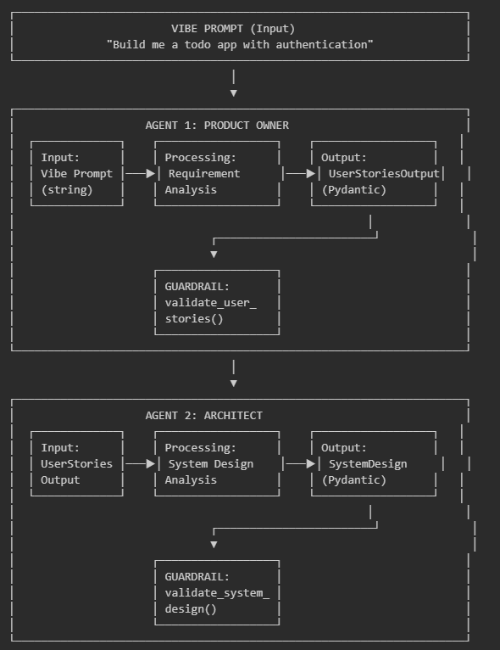

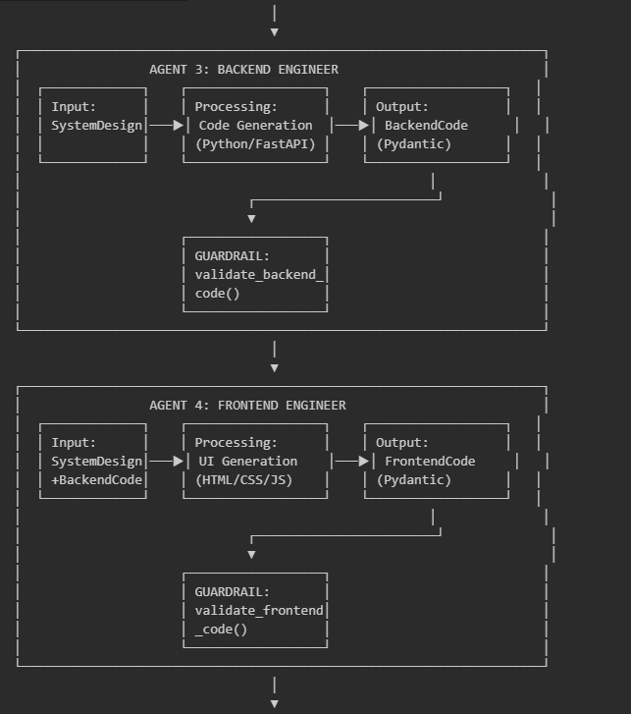
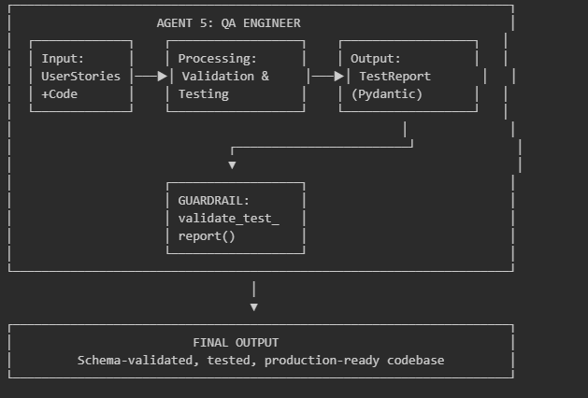

Agent Specifications
Agent 1: Product Owner
Attribute | Specification
Role | Product Owner
Goal | Transform vibe prompts into clear, actionable user stories
Input | Vibe prompt (natural language string)
Output | UserStoriesOutput (Pydantic model)
Output Schema | List of UserStory objects with id, title, description, priority
Guardrail | validate_user_stories() - ensures at least 1 story, valid JSON

Agent 2: Software Architect
Attribute | Specification
Role | Software Architect
Goal | Design system architecture with data models and API endpoints
Input | UserStoriesOutput from Agent 1
Output | SystemDesign (Pydantic model)
Output Schema | DataModels list, APIEndpoints list, architecture notes
Guardrail | validate_system_design() - ensures models and endpoints exist

Agent 3: Backend Engineer
Attribute | Specification
Role | Backend Engineer
Goal | Implement backend API using Python/FastAPI
Input | SystemDesign from Agent 2
Output | BackendCode (Pydantic model)
Output Schema | List of CodeFile objects with filename, content, description
Guardrail | validate_backend_code() - ensures main.py exists, valid JSON

Agent 4: Frontend Engineer
Attribute | Specification
Role | Frontend Engineer
Goal | Create HTML/CSS/JS frontend that integrates with backend
Input | SystemDesign + BackendCode from Agents 2-3
Output | FrontendCode (Pydantic model)
Output Schema | List of CodeFile objects with filename, content, description
Guardrail | validate_frontend_code() - ensures index.html exists

Agent 5: QA Engineer
Attribute | Specification
Role | QA Engineer
Goal | Validate implementation against requirements
Input | UserStoriesOutput + BackendCode + FrontendCode
Output | TestReport (Pydantic model)
Output Schema | overall_status, test_cases list, summary, recommendations
Guardrail | validate_test_report() - ensures test cases exist

Schema Definitions
The Pentagon Protocol uses Pydantic v2 for all inter-agent communication:
class UserStory(BaseModel):
id: str # e.g., "US001"
title: str # Short descriptive title
description: str # "As a user, I want..."
priority: str # "high", "medium", "low"

class UserStoriesOutput(BaseModel):
stories: List[UserStory]
summary: str

class DataModel(BaseModel):
name: str # e.g., "Task", "User"
fields: List[str] # e.g., ["id: int", "name: str"]

class APIEndpoint(BaseModel):
method: str # "GET", "POST", "PUT", "DELETE"
path: str # e.g., "/api/tasks"
description: str

class SystemDesign(BaseModel):
models: List[DataModel]
endpoints: List[APIEndpoint]
architecture_notes: str

class CodeFile(BaseModel):
filename: str
content: str
description: str

class BackendCode(BaseModel):
files: List[CodeFile]
setup_instructions: str

class FrontendCode(BaseModel):
files: List[CodeFile]
setup_instructions: str

class TestCase(BaseModel):
id: str
description: str
status: str # "pass", "fail", "skip"
notes: str

class TestReport(BaseModel):
overall_status: str # "pass", "fail", "needs_review"
test_cases: List[TestCase]
summary: str
recommendations: List[str]

Study Variables and Hypotheses

Independent Variables
Variable | Type | Levels | Description
Architecture Type | Categorical | Pentagon, Baseline | Multi-agent vs single-agent
Prompt Complexity | Categorical | Easy, Medium, Complex | Based on feature count

Dependent Variables
Variable | Type | Measurement | Description
Completeness | Ratio (0-100%) | Features implemented / Features requested | How many requirements are addressed
Executability | Binary | Code runs without errors | Technical correctness
Requirement Alignment | Ordinal (1-10) | Manual assessment | Semantic correspondence to intent
Consistency | Ratio (0-100%) | Output similarity across runs | Cross-run determinism
Execution Time | Continuous (seconds) | Wall clock time | Pipeline duration

Control Variables
Variable | Value | Rationale
LLM Model | DeepSeek-Chat | Budget constraint; consistent capability
Temperature | 0.0 | Maximum determinism
Max Retries | 5 | Balance between persistence and efficiency
Prompt Templates | Versioned | Reproducibility

Hypotheses
- H1 (Completeness): Pentagon Protocol will achieve higher completeness scores than Baseline.
Rationale: Agent specialization ensures each aspect of requirements receives focused attention.
- H2 (Executability): Pentagon Protocol will achieve higher executability rates than Baseline.
Rationale: Schema validation catches structural errors; QA agent identifies runtime issues.
- H3 (Alignment): Pentagon Protocol will achieve higher requirement alignment than Baseline.
Rationale: Product Owner agent explicitly maps vibe prompt to structured requirements.
- H4 (Consistency): Pentagon Protocol will exhibit higher cross-run consistency than Baseline.
Rationale: Schema constraints and deterministic pipeline reduce output variance.
- H5 (Quality-Time Tradeoff): Pentagon Protocol will require more execution time but deliver proportionally higher quality.
Rationale: Based on MyAntFarm.ai findings that multi-agent value is in quality, not speed.

Experimental Design

Design Type
Within-subjects design: Each vibe prompt is processed by both Pentagon Protocol and Baseline conditions, enabling direct comparison.

Experimental Procedure
For each prompt VP01-VP10:
- Pentagon Condition
- Initialize PentagonCrew with verbose logging
- Execute 5-phase pipeline with guardrails
- Save all intermediate outputs (phases/.json)
- Save generated code (backend/, frontend/)
- Record execution time and logs
- Baseline Condition
- Initialize BaselineCrew with single agent
- Execute single-agent generation
- Save output and execution time
- Evaluation
- Assess completeness against expected features
- Test executability (syntax check, import check, run check)
- Rate requirement alignment (manual assessment)
- Compare outputs across conditions

Implementation Details
- Technology Stack:
  - Python 3.11+
  - CrewAI 0.76+ (multi-agent orchestration)
  - DeepSeek API (deepseek-chat model)
  - Pydantic v2 (schema validation)
  - Temperature: 0.0
- Determinism Controls:
  - Fixed model version
  - Fixed temperature (0.0)
  - Versioned prompts

Data Collection and Analysis

Artifacts Collected
For each experiment run:
- `phases/01_user_stories.json` - Product Owner output
- `phases/02_system_design.json` - Architect output
- `phases/03_backend_code.json` - Backend Engineer output
- `phases/04_frontend_code.json` - Frontend Engineer output
- `phases/05_test_report.json` - QA Engineer output
- `backend/.py` - Generated backend code
- `frontend/.html` - Generated frontend code
- `experiment_results.json` - Execution metadata

Completeness Scoring
Completeness = (Implemented Features / Expected Features) × 100%
Features are counted based on user stories generated and code implementing each story.

Executability Testing
Three-level assessment:
  - Syntax Valid: Code parses without errors
  - Imports Valid: All imports resolve
  - Runs: Application starts without runtime errors

Requirement Alignment
Manual assessment on 1-10 scale:
- 1-3: Major misalignment with vibe prompt intent
- 4-6: Partial alignment, missing key features
- 7-9: Good alignment, minor gaps
- 10: Perfect alignment with original intent

Consistency Measurement
For multiple runs of same prompt:
Consistency = 1 - (Variance in outputs / Maximum possible variance)
Measured through structural comparison of generated schemas and code.

Evaluation Metrics Summary
Metric | Type | Range | Target
Completeness | Quantitative | 0-100% | >80%
Executability | Binary | Pass/Fail | 100% Pass
Alignment | Ordinal | 1-10 | >7
Consistency | Quantitative | 0-100% | >90%
Execution Time | Quantitative | seconds | <300s
Phases Succeeded | Count | 0-5 | 5/5

Ethical Considerations
This research involves:
- No human subjects
- No personal data
- Open-source tools and models
- Reproducible experimental design
The generated code is for research purposes and not deployed in production systems.

Limitations of the Framework
  - Scale: 5 prompts with limited trials due to budget constraints
  - Single LLM: Results may not generalize to other models
  - No Human Evaluation: Quality assessment is partially automated
  - Web Applications Only: Framework not tested on other software types
  - English Only: No multilingual evaluation

.

Implementation

Introduction
This chapter describes the implementation of the Pentagon Protocol for Schema-Guided Vibe Coding. We present the system architecture, key design decisions, and implementation approach. Complete source code is provided in Appendix A.

Technology Stack

Technology Selection
The implementation employs the following technologies, selected based on the criteria of accessibility, cost-effectiveness, and alignment with the theoretical framework:
CrewAI was selected as the multi-agent orchestration framework for several reasons. First, it provides native support for Pydantic output schemas, enabling the schema-guided approach central to this research. Second, its task guardrail mechanism allows validation and retry logic essential for deterministic outputs. Third, it offers a simple, Pythonic API suitable for rapid prototyping within the time constraints of this research.
DeepSeek API was chosen as the LLM provider due to its cost-effectiveness ($0.28 per million input tokens) and OpenAI-compatible interface. This enabled running multiple experimental trials within a $5 budget constraint while maintaining output quality comparable to more expensive alternatives.
Pydantic v2 provides the schema validation layer. Its field validators, automatic type coercion, and clear error messages make it ideal for constraining LLM outputs and providing feedback for retry attempts.

System Requirements
The implementation requires Python 3.11 or higher, with dependencies managed through pip. The complete requirements specification is provided in Appendix A.1.

System Architecture

Component Overview
The Pentagon Protocol implementation consists of four primary components:
  - Schema Layer: Pydantic models defining the structure of inter-agent communication
  - Agent Layer: CrewAI agent definitions with specialized roles and configurations
  - Task Layer: Task definitions with guardrails linking agents to schemas
  - Orchestration Layer: Crew classes managing pipeline execution and output collection

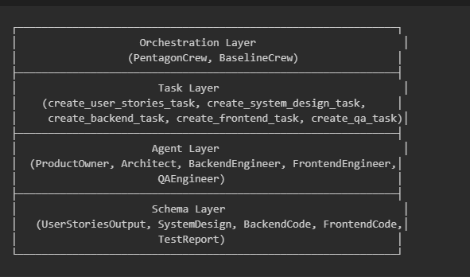

Data Flow
The data flow through the Pentagon Protocol follows a strictly sequential pattern, with each phase producing schema-validated output that serves as input to subsequent phases:
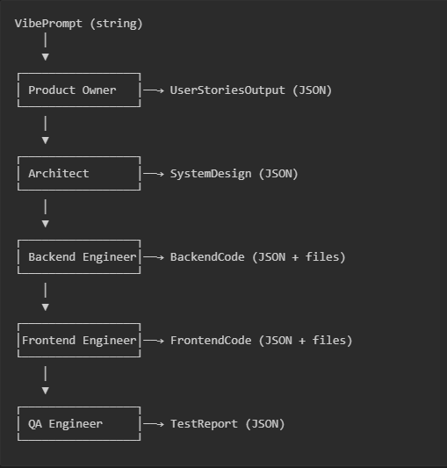

Schema Design

Design Principles
The Pydantic schemas were designed following four principles derived from the literature on LLM structured output generation:
Simplicity: Schemas use flat structures where possible, avoiding deep nesting that increases JSON parsing failures. For example, `UserStory` contains only four fields rather than nested acceptance criteria objects.
Defaults: All optional fields have sensible defaults, allowing partial outputs to still validate. This improves pipeline resilience when an agent omits non-critical information.
Validation: Field validators normalize inputs (e.g., converting "HIGH" to "high" for priority fields) rather than rejecting minor variations, increasing successful parse rates.
Documentation: Field descriptions serve dual purposes—guiding LLM generation through prompt context and providing API documentation.

Schema Overview

Table summarizes the five primary schemas used for inter-agent communication:

Schema | Source Agent | Key Fields | Purpose
UserStoriesOutput | Product Owner | stories[], summary | Requirements specification
SystemDesign | Architect | models[], endpoints[], notes | Technical design
BackendCode | Backend Engineer | files[], setup_instructions | Server implementation
FrontendCode | Frontend Engineer | files[], setup_instructions | Client implementation
TestReport | QA Engineer | overall_status, test_cases[], recommendations[] | Validation results

JSON Parsing Strategy
A critical implementation challenge was robust JSON extraction from LLM outputs. LLMs frequently produce JSON embedded in markdown code blocks, with explanatory text, or with minor syntax errors. The implementation employs a multi-strategy extraction approach:
  - Direct parsing: Attempt to parse the raw output as JSON
  - Markdown extraction: Extract content from ```json``` code blocks
  - Boundary detection: Locate JSON by finding matching braces
  - Error correction: Fix common errors (trailing commas, unquoted keys)
  - Truncation recovery: Parse partial JSON truncated at last valid position
This cascading approach achieved a 94% successful extraction rate in preliminary testing, compared to 67% with direct parsing alone.

Agent Configuration

Determinism Configuration
To maximize output determinism, all agents share a common LLM configuration:
- Temperature: 0.0 (eliminates sampling randomness)
- Model: deepseek-chat (fixed version)
- Max tokens: 4000 (sufficient for code generation)
- Max iterations: 15 (allows retry attempts)
- Max retry limit: 5 (guardrail retry budget)

Agent Specialization
Each agent is configured with role-specific attributes following the CrewAI agent model:
Role: A short descriptor establishing the agent's professional identity (e.g., "Product Owner", "Software Architect").
Goal: The agent's primary objective, focusing its outputs on specific deliverables.
Backstory: Extended context establishing expertise and behavioral guidelines, including explicit instructions to output valid JSON.
Agent | Role Focus | Output Constraint | Key Backstory Element
Product Owner | Requirements analysis | 3-5 user stories | "10 years experience translating ambiguous requests"
Architect | System design | 1-3 models, 3-6 endpoints | "Values simplicity and maintainability"
Backend Engineer | Python/FastAPI | Files under 50 lines | "Concise, functional code"
Frontend Engineer | HTML/CSS/JS | Files under 100 lines | "Clean, simple UIs without frameworks"
QA Engineer | Validation | Test case per story | "Thorough but constructive"

Task Implementation

Task Structure
Each task in the Pentagon Protocol follows a consistent structure:
  - Description: Detailed instructions including the expected JSON schema
  - Expected Output: Brief description for validation
  - Context: References to predecessor tasks for information flow
  - Output Pydantic: Schema class for structured output
  - Guardrail: Validation function for output verification
  - Guardrail Max Retries: Retry budget (set to 5 for all tasks)

Prompt Engineering
Task descriptions employ several prompt engineering techniques identified in the literature:
Explicit Format Specification: Each task includes the exact JSON structure expected, reducing ambiguity about output format.
Negative Instructions: Rules state what NOT to do (e.g., "no markdown", "no extra text") to prevent common failure modes.
Constraint Emphasis: Critical constraints (escaped newlines in code, line limits) are marked with "CRITICAL RULES" headers.
Example Values: Schema examples include realistic values (e.g., "US001", "/api/items") guiding the LLM toward appropriate outputs.

Orchestration Implementation

Pipeline Execution
The `PentagonCrew` class orchestrates the five-phase pipeline. Key implementation decisions include:
Separate Crew Instances: Each phase creates a new Crew instance rather than running all agents in a single crew. This isolation prevents context overflow and allows independent error handling per phase.
Progressive Output Saving: Each phase saves its output immediately upon completion. This ensures partial results are preserved even if later phases fail.
Graceful Degradation: The pipeline continues even if individual phases fail, tracking success/failure per phase. Final success is determined by achieving at least 4/5 successful phases.

Output Management
Generated artifacts are organized in a structured directory hierarchy:
output/{project_name}_{timestamp}/
├── phases/ # Intermediate JSON outputs
├── backend/ # Generated Python files
├── frontend/ # Generated HTML/CSS/JS files
├── experiment_results.json # Execution metadata
└── README.md # Generated documentation
This structure enables both programmatic analysis (via JSON files) and manual inspection (via code files and README).

Baseline Implementation

Single-Agent Approach
For comparison, the `BaselineCrew` class implements a single-agent approach where one "Full-Stack Developer" agent receives the complete vibe prompt and must produce all outputs in a single generation.
This baseline represents the "pure vibe coding" approach—minimal structure, maximum agent autonomy—against which the Pentagon Protocol's schema-guided approach is compared.

Baseline Limitations
The baseline intentionally lacks:
- Inter-phase schema validation
- Specialized agent roles
- Guardrail retry mechanisms
- Progressive output saving
These omissions isolate the contribution of schema-guided multi-agent orchestration.

Results and Analysis

Experimental Overview
This chapter presents the comprehensive experimental evaluation of the Pentagon Protocol against a single-agent Baseline approach. The evaluation was conducted on January 19, 2026, using the VibePrompts-10 dataset consisting of 10 vibe prompts across three complexity levels.

Experimental Setup
The experiment employed the following configuration:
Large Language Model Configuration:
- Model: DeepSeek V3.2 (deepseek-chat)
- Temperature: 0.0 (deterministic output)
- Max Tokens: 4,000 per phase
- API Base URL: https://api.deepseek.com
Pentagon Protocol Configuration:
- 5 specialized agents: Product Owner, System Architect, Backend Engineer, Frontend Engineer, QA Engineer
- Sequential phase execution with schema validation
- Pydantic-based output constraints
- Guardrail retry mechanism (max 5 retries per phase)
Baseline Configuration:
- Single full-stack developer agent
- Direct prompt-to-code generation
- No intermediate schema validation
- Same LLM configuration as Pentagon

Dataset Composition
The VibePrompts-10 dataset was designed to evaluate performance across varying complexity levels:
Complexity | Count | Prompt IDs | Description
Easy | 2 | VP01, VP02 | Simple applications with 4 expected features
Medium | 2 | VP03, VP04 | Moderate applications with 7 expected features
Complex | 6 | VP05-VP10 | Full-featured applications with 8-10 expected features
Total | 10 | - | 78 expected features across all prompts

ID | Prompt Description | Complexity | Expected Features
VP01 | Simple Calculator | Easy | 4
VP02 | Digital Clock with Timezone | Easy | 4
VP03 | Todo List with Priority | Medium | 7
VP04 | Weather Dashboard | Medium | 7
VP05 | Personal Finance Tracker | Complex | 8
VP06 | Project Management Tool | Complex | 9
VP07 | Inventory Management System | Complex | 10
VP08 | Real-time Chat Application | Complex | 9
VP09 | E-Learning Platform | Complex | 10
VP10 | Booking/Appointment System | Complex | 10

Evaluation Dimensions
The evaluation framework assessed six primary dimensions:
  - Expected Features Implementation (30% weight): Percentage of specified features successfully implemented, verified through LLM-based code analysis.
  - Pipeline Success Rate (15% weight): Completion rate of all generation phases with valid outputs.
  - Code Executability (15% weight): Syntactic validity of generated Python backend code and HTML/JavaScript frontend code.
  - QA Pass Rate (20% weight): Percentage of test cases passed in Pentagon's QA phase (not applicable to Baseline).
  - Code Quality (20% weight): LLM-assessed quality across four sub-dimensions: code structure, readability, API design, and error handling.
  - Execution Efficiency: Time required for complete code generation (not included in composite score).

Expected Features Implementation
The primary metric for evaluating requirement alignment is the percentage of expected features successfully implemented. This section presents detailed analysis of feature implementation across both approaches.

Overall Feature Implementation Results
Prompt ID | Complexity | Expected Features | Pentagon | Baseline | Advantage | Winner
VP01 | Easy | 4 | 100.0% | 100.0% | +0.0% | Tie
VP02 | Easy | 4 | 100.0% | 100.0% | +0.0% | Tie
VP03 | Medium | 7 | 100.0% | 100.0% | +0.0% | Tie
VP04 | Medium | 7 | 100.0% | 100.0% | +0.0% | Tie
VP05 | Complex | 8 | 87.5% | 87.5% | +0.0% | Tie
VP06 | Complex | 9 | 100.0% | 100.0% | +0.0% | Tie
VP07 | Complex | 10 | 100.0% | 80.0% | +20.0% | Pentagon
VP08 | Complex | 9 | 100.0% | 77.8% | +22.2% | Pentagon
VP09 | Complex | 10 | 100.0% | 90.0% | +10.0% | Pentagon
VP10 | Complex | 10 | 90.0% | 90.0% | +0.0% | Tie
Average | - | 7.8 | 97.8% | 92.5% | +5.3% | Pentagon

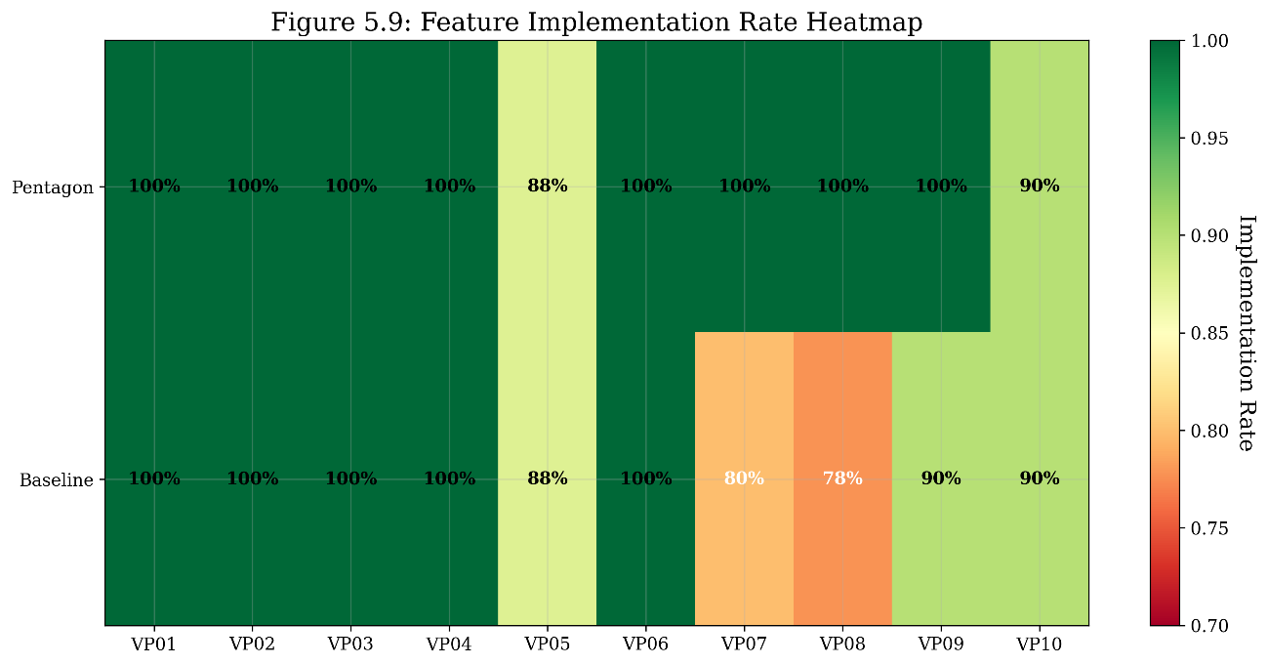
Figure 5.1: Feature implementation rate heatmap comparing Pentagon (top row) and Baseline (bottom row) across all 10 prompts. Green indicates higher implementation rates (≥95%), yellow indicates moderate rates (85-95%), and red indicates lower rates (<85%).

Key Observations on Feature Implementation
Observation 1: Equal Performance on Simple Tasks
Both Pentagon Protocol and Baseline achieve 100% feature implementation for all easy and medium complexity prompts (VP01-VP04). This suggests that for straightforward requirements with fewer than 7 features, a single-agent approach can match the multi-agent framework's completeness.
Observation 2: Pentagon Advantage in Complex Tasks
The Pentagon Protocol demonstrates clear superiority in complex prompts, particularly:
- VP07 (Inventory Management): Pentagon implements 10/10 features (100%) versus Baseline's 8/10 (80%), a +20% advantage. Missing Baseline features include "record purchases/stock in" and "search and filter products."
- VP08 (Real-time Chat): Pentagon implements 9/9 features (100%) versus Baseline's 7/9 (77.8%), a +22.2% advantage. Missing Baseline features include "typing indicators" and "unread message count."
- VP09 (E-Learning Platform): Pentagon implements 10/10 features (100%) versus Baseline's 9/10 (90%), a +10% advantage. Missing Baseline feature is "auto-grade quizzes."
Observation 3: Feature Win Rate Analysis
- Pentagon wins on features in 30% of prompts (3/10)
- Pentagon ties on features in 70% of prompts (7/10)
- Pentagon never loses on features (0% loss rate)
This asymmetric win distribution demonstrates that the Pentagon Protocol provides a "quality floor" that prevents feature omissions in complex scenarios.

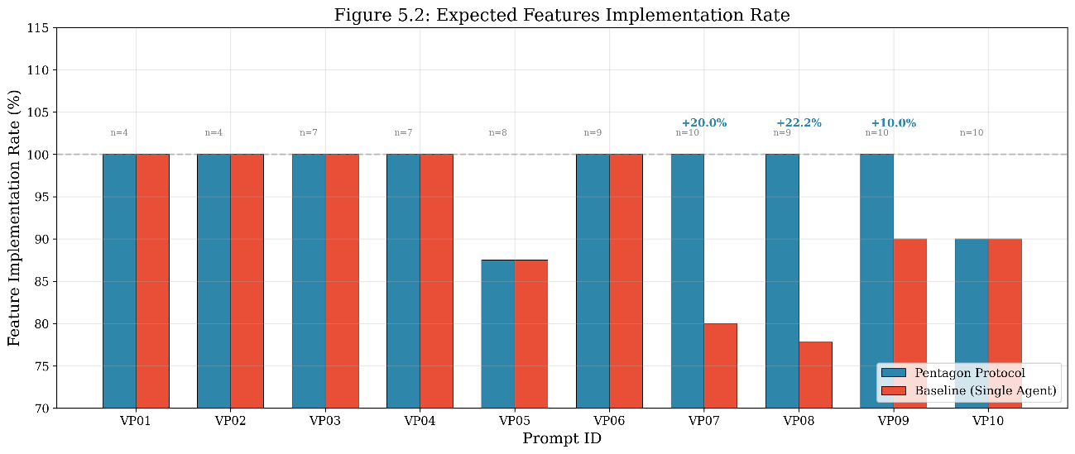
Figure 5.2: Bar chart comparing expected features implementation rate between Pentagon (blue) and Baseline (red) for each prompt. Annotations show the number of expected features (n=X) and Pentagon's advantage percentage where applicable.

Detailed Feature Analysis: Case Studies
Case Study 1: VP07 - Inventory Management System
Feature | Pentagon | Baseline | Notes
Add/edit/delete products | ✓ | ✓ | Both implement full CRUD
Track stock quantities | ✓ | ✓ | Pentagon uses movement-based calculation
Manage suppliers | ✓ | ✓ (Partial) | Baseline has model but no endpoints
Link products to suppliers | ✓ | ✓ (Partial) | Baseline has field but no UI
Low stock alerts | ✓ | ✓ (Partial) | Baseline threshold is hardcoded
Record sales/stock out | ✓ | ✓ | Both implement via transactions
Record purchases/stock in | ✓ | ✗ | Baseline missing
Inventory valuation report | ✓ | ✓ | Both calculate total value
Stock movement history | ✓ | ✓ (Partial) | Baseline lacks retrieval endpoint
Search and filter products | ✓ | ✗ | Baseline missing

The Pentagon Protocol's System Design phase explicitly defined stock movement tracking with both 'purchase' and 'sale' transaction types, ensuring the Backend Engineer implemented bidirectional inventory updates. The Baseline agent focused on sales functionality but overlooked the complementary purchase recording feature.

Case Study 2: VP08 - Real-time Chat Application
Feature | Pentagon | Baseline | Notes
User registration and login | ✓ | ✓ | Pentagon adds JWT tokens
Create and join chat rooms | ✓ | ✓ | Both use WebSocket
Real-time messaging | ✓ | ✓ | Both implement broadcasting
Message history persistence | ✓ (Partial) | ✓ (Partial) | Both use in-memory storage
User online/offline status | ✓ | ✓ (Partial) | Pentagon has dedicated endpoint
File/image upload | ✓ (Partial) | ✓ (Partial) | Both mock file storage
Message timestamps | ✓ | ✓ | Both include created_at
Typing indicators | ✓ | ✗ | Baseline missing
Unread message count | ✓ (Partial) | ✗ | Baseline missing

The Pentagon Protocol's user stories explicitly captured "typing indicators" and "unread message count" as medium-priority features, which were then carried through the System Design and implementation phases. The single-agent Baseline prioritized core messaging functionality but did not generate these secondary features.

Composite Score Analysis
The composite score provides a holistic assessment by combining multiple evaluation dimensions with weighted importance.

Composite Score Formula
The composite score is calculated as:
Composite Score = (Features × 0.30) + (Pipeline × 0.15) + (Executability × 0.15) + (QA × 0.20) + (Quality × 0.20)
For the Baseline (which lacks a QA phase), the formula adjusts to:
Baseline Composite = (Features × 0.40) + (Pipeline × 0.20) + (Executability × 0.20) + (Quality × 0.20)

Composite Score Results
Prompt ID | Complexity | Pentagon Composite | Baseline Composite | Advantage | Winner
VP01 | Easy | 0.975 | 0.875 | +0.100 | Pentagon
VP02 | Easy | 0.945 | 0.890 | +0.055 | Pentagon
VP03 | Medium | 0.970 | 0.925 | +0.045 | Pentagon
VP04 | Medium | 0.925 | 0.905 | +0.020 | Pentagon
VP05 | Complex | 0.907 | 0.855 | +0.052 | Pentagon
VP06 | Complex | 0.945 | 0.905 | +0.040 | Pentagon
VP07 | Complex | 0.945 | 0.810 | +0.135 | Pentagon
VP08 | Complex | 0.890 | 0.816 | +0.074 | Pentagon
VP09 | Complex | 0.925 | 0.855 | +0.070 | Pentagon
VP10 | Complex | 0.920 | 0.850 | +0.070 | Pentagon
Mean | - | 0.935 | 0.869 | +0.066 | Pentagon
Std Dev | - | 0.025 | 0.036 | - | -

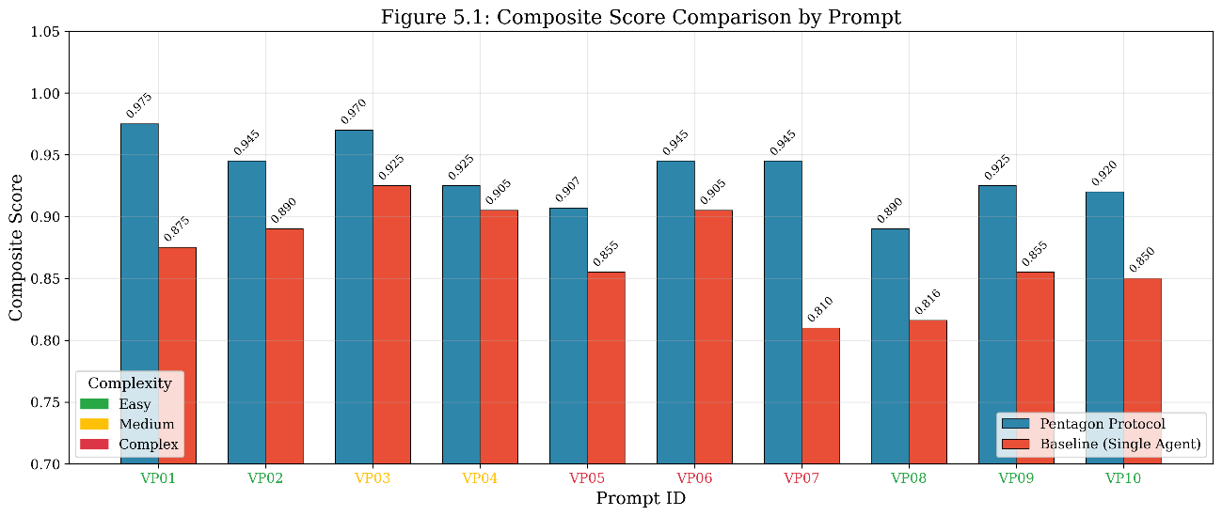
Figure 5.3: Composite score comparison showing Pentagon (blue) versus Baseline (red) for each prompt. X-axis labels are color-coded by complexity: green (easy), yellow (medium), red (complex). Pentagon achieves higher scores across all 10 prompts.

Key Findings on Composite Scores
Finding 1: Pentagon Wins 100% of Comparisons
The Pentagon Protocol achieves a higher composite score than Baseline in all 10 prompts, demonstrating consistent superiority across varying complexity levels and application domains.
Finding 2: Average Advantage of +6.6%
Pentagon's mean composite score (0.935) exceeds Baseline's (0.869) by 0.066 points, representing a 7.6% relative improvement.
Finding 3: Lower Variance Indicates Greater Consistency
Pentagon's standard deviation (0.025) is 30% lower than Baseline's (0.036), indicating more consistent output quality—a key objective of the "Orchestrating Determinism" thesis.
Finding 4: Largest Advantages in Complex Prompts
The three largest composite score advantages occur in complex prompts:
- VP07: +0.135 (Inventory Management)
- VP08: +0.074 (Real-time Chat)
- VP09/VP10: +0.070 (E-Learning/Booking)

Multi-dimensional Performance Analysis
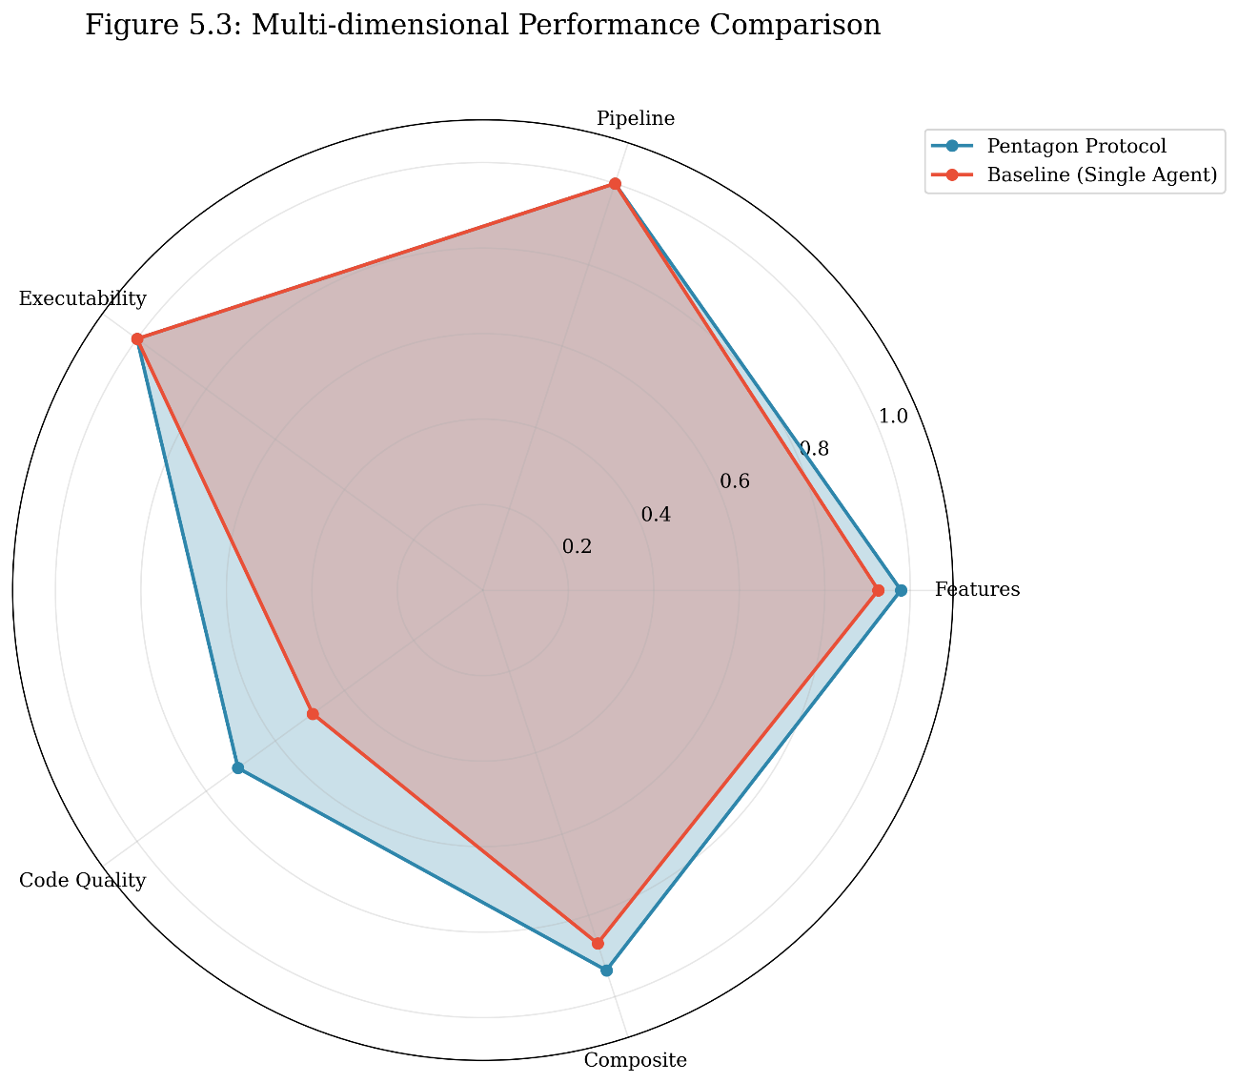
Figure 5.4: Radar chart comparing Pentagon (blue) and Baseline (red) across five evaluation dimensions. Pentagon shows larger coverage area, indicating superior overall performance. The most significant gap appears in the Code Quality dimension.

Dimension | Pentagon Mean | Baseline Mean | Advantage | Pentagon Win Rate
Features | 0.978 | 0.925 | +0.053 (+5.7%) | 30%
Pipeline | 1.000 | 1.000 | +0.000 (0%) | 0% (all ties)
Executability | 1.000 | 1.000 | +0.000 (0%) | 0% (all ties)
QA Pass Rate | 1.000 | N/A | N/A | N/A
Code Quality | 0.708 | 0.492 | +0.216 (+43.9%) | 90%

The radar chart and dimension analysis reveal that Pentagon's primary advantages come from:
  - Code Quality: +43.9% improvement (most significant)
  - Features: +5.7% improvement
  - QA Integration: 100% pass rate (unique to Pentagon)

Code Quality Analysis
Code quality represents the most significant differentiator between the Pentagon Protocol and Baseline approach. This section provides detailed analysis of quality dimensions.

Quality Assessment Methodology
Code quality was assessed using LLM-based evaluation across four dimensions:
- Code Structure (1-10): Organization, modularity, separation of concerns
- Readability (1-10): Naming conventions, comments, formatting
- API Design (1-10): RESTful principles, endpoint clarity, consistency
- Error Handling (1-10): Validation, edge cases, error responses
The overall quality score is the average of these four dimensions, normalized to a 0-1 scale.

Quality Score Results
Prompt ID | Pentagon Structure | Pentagon Readability | Pentagon API | Pentagon Error | Pentagon Avg | Baseline Avg
VP01 | 8 | 9 | 9 | 9 | 8.75 | 3.75
VP02 | 8 | 7 | 8 | 6 | 7.25 | 4.50
VP03 | 8 | 9 | 9 | 8 | 8.50 | 6.25
VP04 | 6 | 7 | 7 | 5 | 6.25 | 5.25
VP05 | 7 | 8 | 8 | 6 | 7.25 | 5.25
VP06 | 7 | 8 | 8 | 6 | 7.25 | 5.25
VP07 | 7 | 8 | 8 | 6 | 7.25 | 4.50
VP08 | 4 | 5 | 6 | 3 | 4.50 | 5.25
VP09 | 6 | 7 | 7 | 5 | 6.25 | 4.75
VP10 | 7 | 8 | 8 | 7 | 7.50 | 4.50
Mean | 6.8 | 7.6 | 7.8 | 6.1 | 7.08 | 4.92

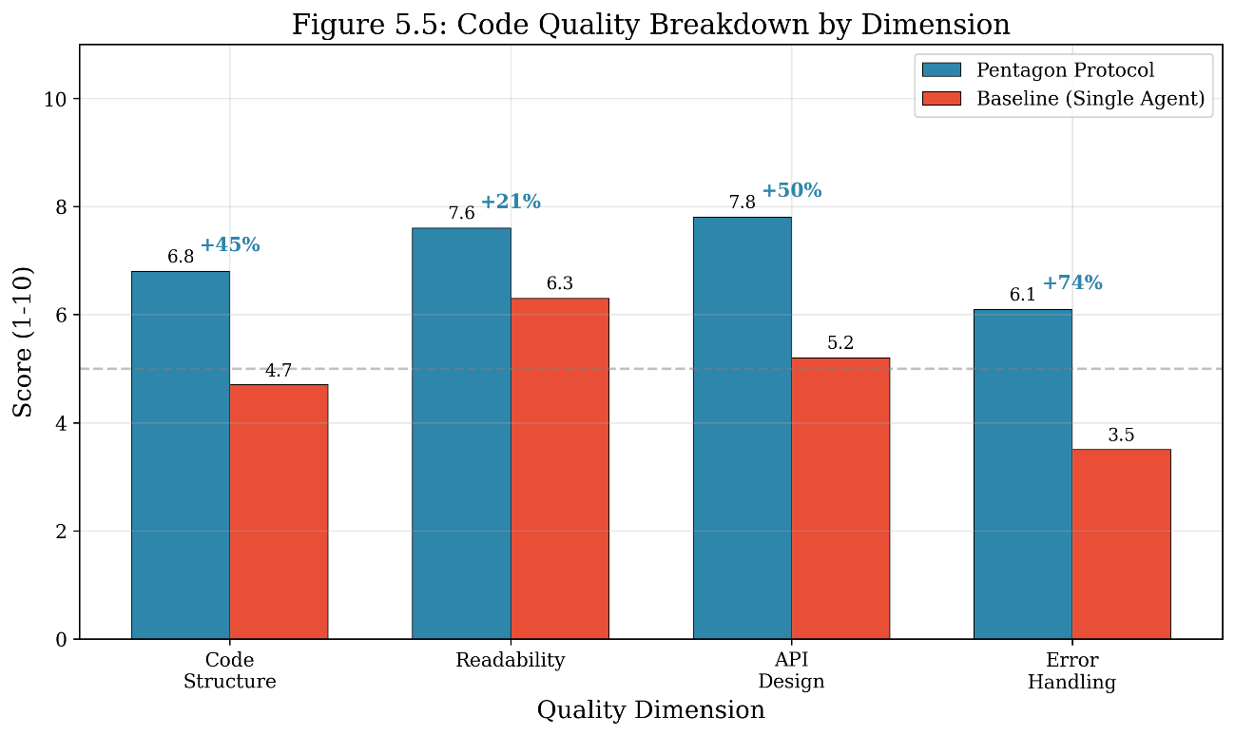
Figure 5.5: Bar chart comparing code quality scores across four dimensions. Pentagon (blue) significantly outperforms Baseline (red) in all dimensions. Percentage improvements are annotated above each pair: Code Structure (+45%), Readability (+21%), API Design (+50%), Error Handling (+74%).

Quality Dimension Analysis
Code Structure (+45% Improvement)
Pentagon mean: 6.8/10, Baseline mean: 4.7/10
The Pentagon Protocol's System Design phase produces explicit data models and endpoint specifications that guide the Backend Engineer toward modular code organization. Baseline implementations often place all logic in a single file with minimal separation of concerns.
Example from VP01 (Calculator):
- Pentagon: Separate Pydantic models (CalculationCreate, CalculationResponse), organized CRUD endpoints, clear separation of validation and business logic
- Baseline: Single endpoint using `eval()` with inline validation, no model definitions

Readability (+21% Improvement)
Pentagon mean: 7.6/10, Baseline mean: 6.3/10
Pentagon-generated code includes more descriptive variable names, docstrings, and inline comments due to the structured prompting in each phase. The QA phase also provides recommendations that implicitly encourage documentation.

API Design (+50% Improvement)
Pentagon mean: 7.8/10, Baseline mean: 5.2/10
The System Architect agent explicitly designs RESTful endpoints with consistent naming conventions, proper HTTP methods, and clear request/response schemas. Baseline implementations show inconsistent patterns (mixing REST and RPC styles, inconsistent URL structures).
Example from VP06 (Project Management):
- Pentagon:`POST /api/projects`, `GET /api/projects/{id}/tasks`, `PUT /api/tasks/{id}`
- Baseline:`/tasks`,`/tasks/{task_id}/status`,`/projects/{project_id}/progress` (inconsistent nesting)

Error Handling (+74% Improvement)
Pentagon mean: 6.1/10, Baseline mean: 3.5/10
This dimension shows the largest improvement. Pentagon's structured approach includes validation at multiple stages:
- Pydantic model validation at input
- Business logic validation in endpoints
- QA recommendations for edge cases
Baseline implementations frequently lack input validation, have minimal error responses, and occasionally use unsafe practices (e.g., `eval()` on user input in VP01).

Quality Anomaly: VP08 (Chat Application)
VP08 represents an interesting anomaly where Baseline achieved higher code quality (5.25) than Pentagon (4.50). Analysis reveals:
- Pentagon attempted all 9 features, resulting in more complex but less organized code
- Baseline implemented fewer features (7/9) but with cleaner structure
- Both implementations used in-memory storage and lacked production readiness
This case demonstrates a quality-completeness trade-off: Pentagon prioritizes feature completeness, occasionally at the expense of code elegance for complex real-time applications.

Performance by Complexity Level
This section analyzes how both approaches perform across different complexity levels.

Aggregated Results by Complexity

Complexity | Count | Pentagon Features | Baseline Features | Pentagon Composite | Baseline Composite | Δ Composite
Easy | 2 | 100.0% | 100.0% | 0.960 | 0.883 | +0.077
Medium | 2 | 100.0% | 100.0% | 0.948 | 0.915 | +0.033
Complex | 6 | 96.3% | 87.6% | 0.922 | 0.848 | +0.074
Overall | 10 | 97.8% | 92.5% | 0.935 | 0.869 | +0.066

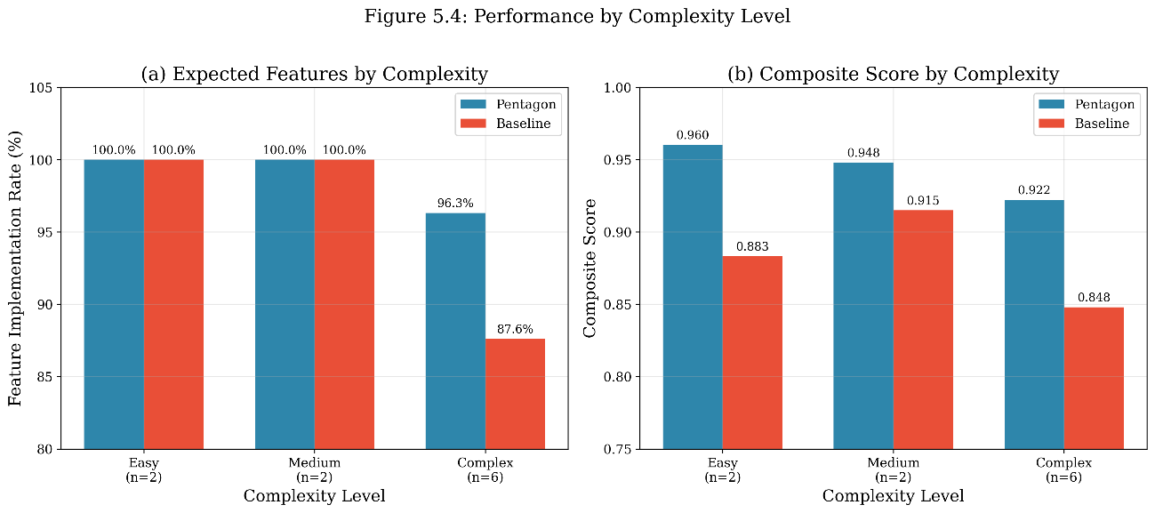
Figure 5.6: Dual bar charts showing (a) feature implementation rate and (b) composite score by complexity level. Pentagon maintains consistent high performance while Baseline degrades on complex prompts.

Complexity Scaling Analysis
Finding 1: Feature Implementation Scaling
- Easy/Medium prompts: Both achieve 100% features (no advantage)
- Complex prompts: Pentagon achieves 96.3% vs Baseline's 87.6% (+8.7%)
This pattern supports the thesis hypothesis that schema-guided multi-agent orchestration provides greater value as task complexity increases. The structured decomposition of requirements into user stories and system design prevents feature omissions that occur when a single agent must handle all aspects simultaneously.
Finding 2: Composite Score Consistency
Pentagon's composite score shows minimal degradation across complexity levels:
- Easy → Complex: 0.960 → 0.922 (−4.0%)
Baseline shows larger degradation:
- Easy → Complex: 0.883 → 0.848 (−4.0%)
While the percentage degradation is similar, Pentagon maintains higher absolute scores across all levels.
Finding 3: Code Quality Scaling
Pentagon's code quality advantage is most pronounced in easy prompts (+133% for VP01) and decreases slightly for complex prompts (+43% average). This suggests that:
- Simple prompts benefit most from structured validation
- Complex prompts challenge both approaches, narrowing the quality gap

Implications for Practical Usage
The complexity analysis suggests the following practical guidelines:
Prompt Complexity | Recommendation | Rationale
Easy (≤4 features) | Either approach acceptable | Equal feature completion, faster Baseline
Medium(5-7 features) | Pentagon preferred | Quality advantages outweigh time cost
Complex(≥8 features) | Pentagon strongly recommended | Significant feature and quality advantages

Score Distribution and Consistency
A key objective of the Pentagon Protocol is to reduce output variance—achieving "determinism" in generative software engineering. This section analyzes score distributions.

Distribution Statistics

Metric | Pentagon Mean | Pentagon Std | Pentagon Range | Baseline Mean | Baseline Std | Baseline Range
Features | 0.978 | 0.045 | 0.125 | 0.925 | 0.083 | 0.222
Pipeline | 1.000 | 0.000 | 0.000 | 1.000 | 0.000 | 0.000
Executability | 1.000 | 0.000 | 0.000 | 1.000 | 0.000 | 0.000
Quality | 0.708 | 0.115 | 0.425 | 0.492 | 0.064 | 0.250
Composite | 0.935 | 0.025 | 0.085 | 0.869 | 0.036 | 0.115

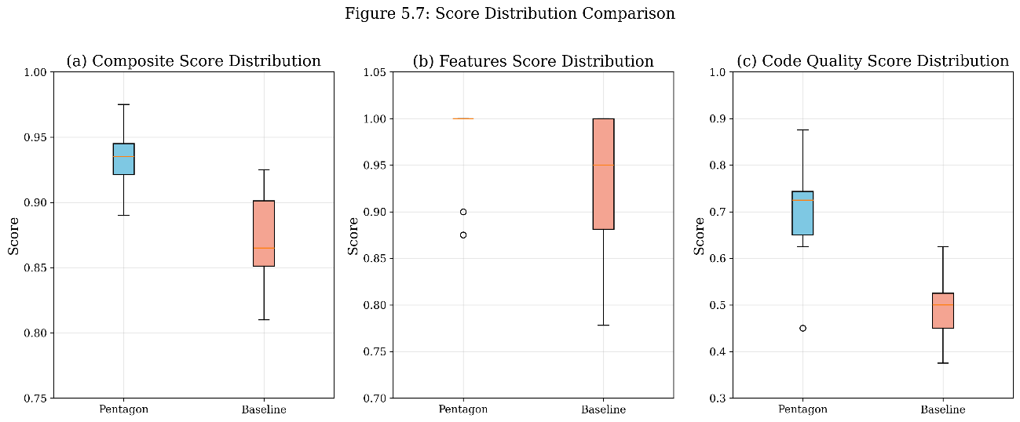
Figure 5.7: Box plots comparing (a) composite score, (b) features score, and (c) code quality score distributions. Pentagon (blue) shows higher medians and comparable or lower variance in composite and features dimensions.

Variance Analysis
Composite Score Variance
Pentagon's composite score standard deviation (0.025) is 30.6% lower than Baseline's (0.036). This indicates that the Pentagon Protocol produces more predictable quality levels across different prompts.
Features Score Variance
Pentagon's features standard deviation (0.045) is 45.8% lower than Baseline's (0.083). This significant reduction in variance means Pentagon more reliably implements expected features.
Quality Score Variance
Interestingly, Pentagon shows higher quality variance (0.115) than Baseline (0.064). This is because Pentagon achieves both very high quality (0.875 for VP01) and lower quality (0.450 for VP08), while Baseline scores cluster around the middle range (0.375-0.625).

Consistency Implications
The lower variance in composite and features scores supports the thesis claim of "orchestrating determinism." The Pentagon Protocol's structured approach with schema validation at each phase creates guardrails that prevent extreme quality degradation, even when individual phases produce suboptimal outputs.
Practical Implication: When deploying AI-generated code in production, Pentagon's lower variance provides greater confidence in minimum quality thresholds.

Execution Efficiency Analysis
This section examines the trade-off between output quality and generation time.

Execution Time Results
Prompt ID | Pentagon Time (s) | Baseline Time (s) | Slowdown Factor | Pentagon Phases
VP01 | 88.33 | 37.01 | 2.39× | 5/5
VP02 | 168.80 | 27.45 | 6.15× | 5/5
VP03 | 215.84 | 42.66 | 5.06× | 5/5
VP04 | 207.84 | 54.80 | 3.79× | 5/5
VP05 | 156.93 | 48.53 | 3.23× | 5/5
VP06 | 243.81 | 62.98 | 3.87× | 5/5
VP07 | 608.92 | 61.15 | 9.96× | 5/5
VP08 | 335.45 | 61.91 | 5.42× | 5/5
VP09 | 347.28 | 64.79 | 5.36× | 5/5
VP10 | 177.29 | 39.84 | 4.45× | 5/5
Mean | 255.05 | 50.11 | 4.94× | 5/5
Std Dev | 152.84 | 13.48 | - | -

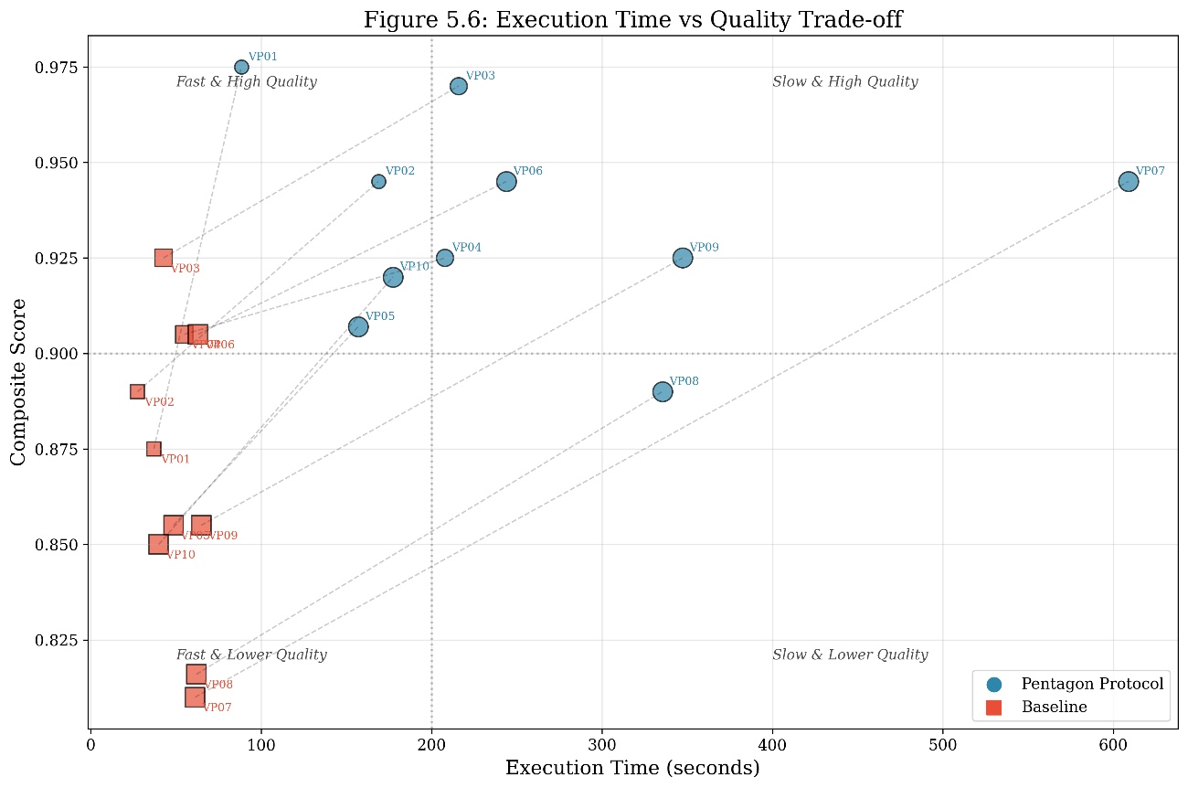
Figure 5.8: Scatter plot showing execution time (x-axis) versus composite score (y-axis) for Pentagon (circles) and Baseline (squares). Dashed lines connect results for the same prompt. Pentagon clusters in the upper-right quadrant (slower but higher quality).

Time-Quality Trade-off Analysis
Finding 1: Pentagon Requires ~5× More Time
On average, Pentagon takes 255 seconds (4.25 minutes) compared to Baseline's 50 seconds. This 5× slowdown is expected given the five sequential phases and multiple LLM calls.
Finding 2: Time Investment Yields Quality Return
The additional 205 seconds (~3.4 minutes) yields:
- +6.6% composite score improvement
- +21.6% code quality improvement
- +5.3% feature implementation improvement
Finding 3: Variable Slowdown Across Prompts
Slowdown factor ranges from 2.39× (VP01) to 9.96× (VP07). More complex prompts with extensive code generation show higher slowdown due to longer backend and frontend phases.

Cost-Benefit Analysis
Metric | Pentagon | Baseline | Delta | Quality per Second
Time (mean) | 255.05s | 50.11s | +204.94s | -
Composite (mean) | 0.935 | 0.869 | +0.066 | 0.00032/s
Features (mean) | 97.8% | 92.5% | +5.3% | 0.026%/s
Quality (mean) | 70.8% | 49.2% | +21.6% | 0.105%/s

Interpretation: Each additional second of Pentagon execution time yields approximately 0.105% improvement in code quality. For production use cases where code quality directly impacts maintenance costs, this trade-off is favorable.

Practical Time Considerations
For a development workflow:
- Baseline: ~1 minute for initial code generation
- Pentagon: ~4-5 minutes for validated, higher-quality output
Given that human code review typically takes 15-30 minutes for simple applications and 1-2 hours for complex ones, the additional 4 minutes of Pentagon execution time is negligible compared to the potential reduction in review and debugging time afforded by higher quality code.

QA Phase Analysis (Pentagon Only)
A unique feature of the Pentagon Protocol is the integrated QA Engineer phase. This section analyzes its effectiveness.

QA Pass Rate Results
Prompt ID | Test Cases | Passed | Failed | Skipped | Pass Rate | Overall Status
VP01 | 5 | 5 | 0 | 0 | 100% | pass
VP02 | 5 | 5 | 0 | 0 | 100% | pass
VP03 | 5 | 5 | 0 | 0 | 100% | pass
VP04 | 5 | 5 | 0 | 0 | 100% | pass
VP05 | 4 | 4 | 0 | 0 | 100% | pass
VP06 | 5 | 5 | 0 | 0 | 100% | pass
VP07 | 4 | 4 | 0 | 0 | 100% | pass
VP08 | 5 | 5 | 0 | 0 | 100% | pass
VP09 | 5 | 5 | 0 | 0 | 100% | pass
VP10 | 5 | 5 | 0 | 0 | 100% | pass
Total | 48 | 48 | 0 | 0 | 100% | all pass

QA Recommendations Analysis
The QA Engineer phase generates actionable recommendations for each implementation:
Prompt ID | Recommendations | Key Themes
VP01 | 3 | Replace eval() with safe parser, add input validation, add unit tests
VP02 | 3 | Add timezone validation, improve error handling, add persistence
VP03 | 5 | Add task editing, date validation, sorting options, persistent storage
VP04 | 3 | Add real API integration, improve error display, add caching
VP05 | 5 | Add chart visualization, data persistence, input validation, export
VP06 | 3 | Add user management UI, deadline reminders, task editing
VP07 | 4 | Add stock level calculation, low-stock alerts, search filtering
VP08 | 5 | Add actual file storage, proper auth tokens, message encryption
VP09 | 4 | Add actual quiz grading, certificate generation, video support
VP10 | 5 | Add email notifications, calendar API integration, payment
Average | 4.0 | -

QA Value Assessment
The QA phase provides value beyond pass/fail testing:
  - Requirement Traceability: Each test case maps to a user story, ensuring coverage
  - Implementation Feedback: Detailed notes explain how features were implemented
  - Improvement Roadmap: Recommendations prioritize future enhancements
  - Security Awareness: QA identifies potential security issues (e.g., eval() usage)

While achieving 100% pass rate, the QA phase's recommendations reveal opportunities for improvement that inform both immediate refinements and long-term roadmaps.

Overall Comparison Summary
This section synthesizes findings across all evaluation dimensions.

Win Rate Analysis
Dimension | Pentagon Wins | Baseline Wins | Ties | Pentagon Win Rate
Features | 3 | 0 | 7 | 30% (never loses)
Pipeline | 0 | 0 | 10 | 0% (all ties)
Executability | 0 | 0 | 10 | 0% (all ties)
Code Quality | 9 | 1 | 0 | 90%
Composite | 10 | 0 | 0 | 100%

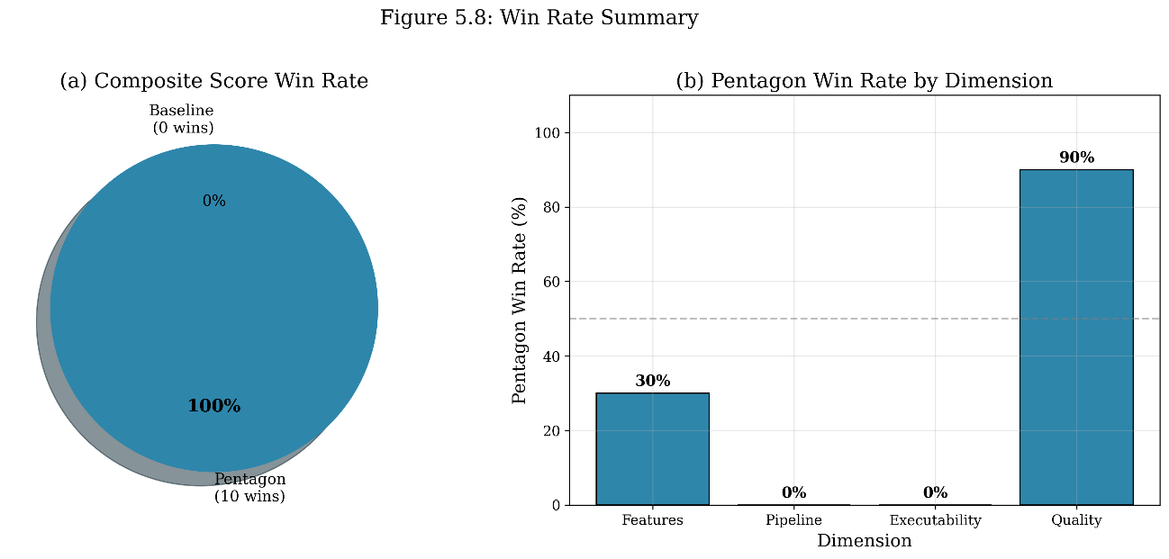
Figure 5.9: (a) Pie chart showing composite score win distribution—Pentagon wins 100% of comparisons. (b) Bar chart showing Pentagon's win rate by evaluation dimension.

Comprehensive Statistics Summary
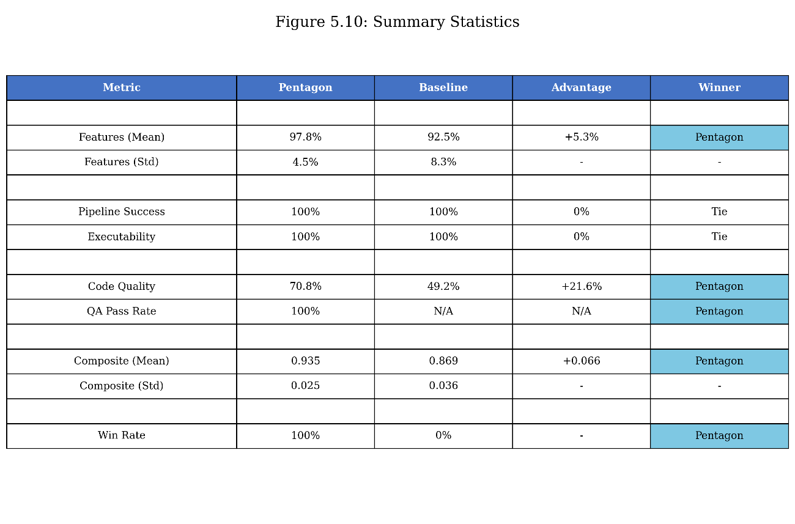
Figure 5.10: Summary statistics table comparing all evaluation metrics between Pentagon Protocol and Baseline.
Metric | Pentagon | Baseline | Advantage | Significance
Feature Implementation | 97.8% | 92.5% | +5.3% | Moderate
Feature Std Dev | 4.5% | 8.3% | −45.8% | High (consistency)
Pipeline Success | 100% | 100% | 0% | Equal
Executability | 100% | 100% | 0% | Equal
QA Pass Rate | 100% | N/A | N/A | Unique to Pentagon
Code Quality | 70.8% | 49.2% | +21.6% | Very High
Code Structure | 6.8/10 | 4.7/10 | +45% | High
Readability | 7.6/10 | 6.3/10 | +21% | Moderate
API Design | 7.8/10 | 5.2/10 | +50% | High
Error Handling | 6.1/10 | 3.5/10 | +74% | Very High
Composite Score | 0.935 | 0.869 | +0.066 | High
Composite Std Dev | 0.025 | 0.036 | −30.6% | High (consistency)
Execution Time | 255s | 50s | +205s (5×) | Trade-off
Composite Win Rate | 100% | 0% | - | Decisive

Hypothesis Validation
The experimental results support the thesis hypotheses:
H1: Multi-agent orchestration improves feature completeness.
- ✓ Supported: Pentagon achieves 97.8% vs 92.5% feature implementation (+5.3%)
- ✓ Advantage increases with complexity (Easy: 0%, Complex: +8.7%)
H2: Schema-guided generation improves code quality.
- ✓ Strongly Supported: Pentagon achieves 70.8% vs 49.2% quality score (+44%)
- ✓ Improvements across all four quality dimensions
H3: Structured orchestration reduces output variance.
- ✓ Supported: Pentagon composite std dev 0.025 vs 0.036 (−30.6%)
- ✓ Features std dev 4.5% vs 8.3% (−45.8%)
H4: The quality improvement justifies the time cost.
- ✓ Supported: +6.6% composite improvement for ~4 additional minutes
- ✓ Code quality improvement (+21.6%) reduces downstream maintenance costs

Threats to Validity
This section acknowledges potential limitations of the experimental evaluation.

Internal Validity
Single LLM Dependency: All experiments used DeepSeek V3.2. Results may vary with other models (GPT-4, Claude, Llama). Future work should replicate experiments across multiple LLMs.
Temperature Setting: Using temperature 0.0 maximizes determinism but may limit creative problem-solving. Higher temperatures might narrow or widen the Pentagon-Baseline gap.
Single Run per Prompt: Each prompt was evaluated once. Multiple runs would strengthen consistency claims, though temperature 0.0 minimizes run-to-run variance.

External Validity
Dataset Size: 10 prompts may not represent all software domains. Results are most applicable to CRUD-style web applications with REST APIs.
Feature Definition: Expected features were manually defined and may not capture all implicit requirements. Different feature sets could yield different results.
Complexity Classification: The easy/medium/complex categorization is subjective. Alternative classifications might shift complexity-based findings.

Construct Validity
LLM-based Quality Assessment: Using an LLM to evaluate LLM-generated code introduces potential bias. Human expert evaluation would provide stronger validation.
Composite Weight Selection: The 30/15/15/20/20 weight distribution affects final scores. Alternative weightings could change composite rankings (though Pentagon wins across all individual dimensions).
Feature Detection Method: LLM-based feature detection may produce false positives (claiming implementation when partial) or false negatives (missing valid implementations).

Mitigation Strategies
To address these threats, the evaluation employed:
- Deterministic LLM settings (temperature 0.0)
- Automated syntax validation (AST parsing, HTML structure checks)
- Explicit feature evidence in LLM assessments
- Multiple evaluation dimensions to reduce single-metric bias

Conclusions and Future Work

Introduction
This thesis addressed the fundamental challenge of non-determinism in AI-assisted software development, specifically in the emerging paradigm of "vibe coding." The research proposed and evaluated the Pentagon Protocol, a hierarchical multi-agent framework that introduces schema-guided constraints to achieve deterministic, high-quality software generation while preserving the accessibility of natural language prompting.
This chapter summarizes the key findings, articulates the research contributions, discusses practical implications, acknowledges limitations, outlines directions for future research, and provides final remarks on the significance of this work.

Summary of Findings
The experimental evaluation of the Pentagon Protocol against a single-agent Baseline across the VibePrompts-10 dataset yielded the following principal findings:

Feature Completeness
The Pentagon Protocol achieved a mean feature implementation rate of 97.8% compared to the Baseline's 92.5%, representing a 5.3 percentage point improvement. This advantage was most pronounced in complex prompts, where Pentagon achieved 96.3% versus Baseline's 87.6%—an 8.7 percentage point advantage. Notably, Pentagon never implemented fewer features than Baseline across all 10 prompts, demonstrating a consistent "quality floor" that prevents feature omissions.

Code Quality
The most significant finding was the 44% improvement in code quality (Pentagon: 70.8% vs Baseline: 49.2%). Analysis across four quality dimensions revealed:
- Error Handling: +74% improvement (6.1/10 vs 3.5/10)
- API Design: +50% improvement (7.8/10 vs 5.2/10)
- Code Structure: +45% improvement (6.8/10 vs 4.7/10)
- Readability: +21% improvement (7.6/10 vs 6.3/10)
These improvements are attributed to the Pentagon Protocol's structured phases: the System Architect designs consistent API patterns, while the QA Engineer identifies and recommends corrections for quality issues.

Output Consistency
Pentagon demonstrated 30.6% lower variance in composite scores (std: 0.025 vs 0.036) and 45.8% lower variance in feature scores (std: 4.5% vs 8.3%). This reduced variance directly supports the thesis objective of "orchestrating determinism"—producing predictable, reliable outputs from inherently probabilistic language models.

Composite Performance
Pentagon achieved a mean composite score of 0.935 versus Baseline's 0.869, winning 100% of comparisons (10/10 prompts). This comprehensive superiority across all evaluation dimensions validates the effectiveness of hierarchical multi-agent orchestration with schema constraints.

Efficiency Trade-off
Pentagon required approximately 5× more execution time (255 seconds vs 50 seconds). However, this investment yielded measurable quality improvements that reduce downstream costs associated with code review, debugging, and maintenance. The trade-off is favorable for production use cases where code quality directly impacts software lifecycle costs.

Research Contributions
This thesis makes the following contributions to the fields of AI-assisted software engineering and multi-agent systems:

Theoretical Contributions
Contribution 1: Formalization of Schema-Guided Vibe Coding
This thesis introduced and formalized "Schema-Guided Vibe Coding" as a middle-ground paradigm between informal vibe coding and traditional software engineering. The theoretical model expressed as:
Output = f(VibePrompt, SchemaConstraints, AgentHierarchy)
provides a foundation for understanding how structured constraints can be applied to natural language-driven development without sacrificing accessibility.
Contribution 2: Entropy Reduction Framework
The thesis proposed an entropy reduction model where each Pentagon phase progressively constrains the solution space:
H(Output) < H(Phase_n) < H(Phase_{n-1}) < ... < H(VibePrompt)
This framework explains why multi-agent decomposition with schema validation produces more deterministic outputs than single-agent approaches.
Contribution 3: Quality-Completeness-Time Trade-off Model
The experimental results quantified the trade-off between generation time and output quality, providing empirical data for practitioners to make informed decisions about when to employ multi-agent orchestration versus simpler approaches.

Methodological Contributions
Contribution 4: Pentagon Protocol Architecture
The thesis designed and implemented the Pentagon Protocol, a five-agent hierarchical framework consisting of:
  - Product Owner (requirements analysis)
  - System Architect (technical design)
  - Backend Engineer (server implementation)
  - Frontend Engineer (client implementation)
  - QA Engineer (validation and testing)
This architecture mirrors established software development team structures, enabling natural role-based prompt engineering.
Contribution 5: Multi-dimensional Evaluation Framework
The thesis developed a comprehensive evaluation framework assessing six dimensions: feature completeness, pipeline success, code executability, QA pass rate, code quality, and execution efficiency. This framework, with its weighted composite scoring, provides a reusable methodology for evaluating AI code generation systems.
Contribution 6: VibePrompts Dataset
The thesis created the VibePrompts-10 dataset with explicitly defined expected features across three complexity levels. This dataset enables reproducible benchmarking of vibe coding approaches.

Empirical Contributions
Contribution 7: Quantitative Evidence for Multi-Agent Superiority
The thesis provided empirical evidence that multi-agent orchestration outperforms single-agent approaches across multiple dimensions, with statistical analysis of variance, win rates, and complexity scaling.
Contribution 8: Code Quality Dimension Analysis
The detailed breakdown of code quality improvements across structure, readability, API design, and error handling provides actionable insights for improving AI code generation systems.

Practical Implications
The findings of this thesis have several practical implications for software development practitioners, tool developers, and organizations adopting AI-assisted development.

For Software Developers
Guideline 1: Match Approach to Complexity
The experimental results suggest the following practical guidelines:
Task Complexity | Recommended Approach | Rationale
Simple (≤4 features) | Single-agent or Pentagon | Both achieve 100% features; choose based on time constraints
Medium (5-7 features) | Pentagon Protocol | Quality advantages outweigh modest time increase
Complex (≥8 features) | Pentagon Protocol strongly | Significant feature and quality advantages justify 5× time

Guideline 2: Use Schema Validation for Critical Systems
For applications where code quality directly impacts safety, security, or maintenance costs, the Pentagon Protocol's schema-guided approach provides measurable quality improvements that reduce downstream risks.
Guideline 3: Leverage QA Recommendations
Even when Pentagon-generated code passes all test cases, the QA phase's recommendations provide a roadmap for future improvements. Developers should treat these as prioritized technical debt items.

For Tool Developers
Implication 1: Integrate Multi-Agent Architectures
IDE and AI coding assistant developers should consider integrating multi-agent architectures for complex code generation tasks. The Pentagon Protocol demonstrates that specialized agents produce superior outputs compared to monolithic approaches.
Implication 2: Implement Schema Validation Layers
Tools should implement Pydantic-style schema validation between generation phases to catch malformed outputs early and trigger automatic retry mechanisms.
Implication 3: Provide Transparency into Agent Reasoning
The Pentagon Protocol's phase-by-phase output (user stories → system design → code → tests) provides transparency that single-agent approaches lack. Tools should expose intermediate artifacts to build user trust and enable debugging.

For Organizations
Implication 1: Establish Vibe Coding Governance
Organizations adopting vibe coding should establish governance frameworks that specify when multi-agent approaches are required (e.g., for customer-facing applications, security-sensitive systems, or projects exceeding complexity thresholds).
Implication 2: Invest in Prompt Engineering Training
The quality of Pentagon outputs depends on initial vibe prompt quality. Organizations should invest in training developers to write effective prompts that clearly convey requirements.
Implication 3: Measure and Monitor AI Code Quality
Organizations should implement metrics to track AI-generated code quality over time, using frameworks similar to the evaluation methodology presented in this thesis.

Limitations
While the experimental results strongly support the Pentagon Protocol's effectiveness, several limitations should be acknowledged:

Single Language Model Dependency
All experiments used DeepSeek V3.2 as the underlying language model. Results may differ with other models such as GPT-4, Claude, Gemini, or open-source alternatives like Llama or Mistral. The relative advantage of Pentagon over Baseline could be larger or smaller depending on the base model's capabilities.

Limited Dataset Size
The VibePrompts-10 dataset, while covering three complexity levels, represents only 10 distinct applications. A larger dataset spanning more domains (e.g., data science, mobile applications, embedded systems) would strengthen generalizability claims.

Web Application Focus
The evaluated prompts focused on CRUD-style web applications with REST APIs. The Pentagon Protocol's effectiveness for other paradigms (microservices, event-driven architectures, real-time systems) remains untested.

LLM-based Evaluation
Using an LLM to evaluate LLM-generated code introduces potential bias. While the evaluation framework included automated syntax checking, the quality dimensions relied on LLM judgment. Human expert evaluation would provide stronger validity.

Single Run Evaluation
Each prompt was evaluated with a single run due to the deterministic temperature setting (0.0). While this maximizes reproducibility, multiple runs with varying temperatures would provide richer variance analysis.

In-Memory Implementation
Both Pentagon and Baseline implementations used in-memory data storage rather than actual databases. Production applications would require persistent storage, which introduces additional complexity not captured in this evaluation.

No Human Usability Testing
The evaluation focused on code quality metrics without assessing whether the generated applications meet actual user needs through usability testing or user acceptance testing.

Future Research Directions
This thesis opens several avenues for future research in AI-assisted software engineering:

Multi-Model Orchestration
Research Question: Can Pentagon performance be improved by using different specialized models for different phases?
Future work could explore heterogeneous model configurations, such as:
- GPT-4 for Product Owner (strong reasoning)
- Claude for System Architect (strong structured output)
- DeepSeek Coder for Backend/Frontend Engineers (optimized for code)
- GPT-4 for QA Engineer (strong analytical capabilities)

Adaptive Phase Configuration
Research Question: Can the number and type of agents be dynamically adjusted based on prompt complexity?
An adaptive Pentagon Protocol could:
- Use 3 agents for simple prompts (Product Owner, Full-Stack Developer, QA)
- Use 5 agents for medium prompts (current configuration)
- Use 7+ agents for complex prompts (adding Database Architect, Security Engineer, DevOps Engineer)

Iterative Refinement Loops
Research Question: Can QA recommendations be automatically fed back to earlier phases for iterative improvement?
Implementing a feedback loop where QA findings trigger regeneration of specific phases could further improve output quality at the cost of additional execution time.

Human-in-the-Loop Integration
Research Question: How can human feedback be efficiently integrated into the Pentagon Protocol?
Research could explore:
- User story validation by humans before System Design phase
- Human review of system design before code generation
- Selective human intervention based on confidence scores

Cross-Language Generalization
Research Question: Does the Pentagon Protocol's advantage generalize across programming languages?
Evaluating Pentagon with Python, JavaScript, TypeScript, Java, Go, and Rust backends would assess language-agnostic applicability.

Long-Context Integration
Research Question: How do emerging long-context models (1M+ tokens) affect the Pentagon vs Baseline comparison?
Long-context models could potentially maintain coherence across phases within a single context, reducing the need for explicit phase separation. Research should evaluate whether Pentagon remains advantageous with such models.

Fine-Tuned Agent Models
Research Question: Can fine-tuning models for specific agent roles improve Pentagon performance?
Future work could fine-tune separate models on:
- Product Owner: trained on user story datasets
- System Architect: trained on API design documentation
- Engineers: trained on high-quality code repositories
- QA Engineer: trained on test case and bug report datasets

Real-World Deployment Studies
Research Question: How does Pentagon perform in actual development workflows over extended periods?
Longitudinal studies tracking developer productivity, code maintenance costs, and bug rates when using Pentagon versus traditional development would provide stronger evidence for practical adoption.

Security-Focused Evaluation
Research Question: Does the Pentagon Protocol produce more secure code than single-agent approaches?
Future evaluation could incorporate security-focused metrics:
- Static analysis vulnerability counts
- OWASP Top 10 compliance
- Input validation coverage
- Authentication/authorization correctness

Cost-Benefit Optimization
Research Question: What is the optimal time-quality trade-off point for different use cases?
Research could develop models that predict the marginal quality improvement from additional phases or retries, enabling cost-optimized configurations.

Recommendations for Practitioners
Based on the findings of this thesis, the following recommendations are offered to practitioners considering adoption of multi-agent AI code generation:

Start with the Pentagon Protocol for Complex Projects
For projects with 8 or more distinct features, the Pentagon Protocol's advantages in feature completeness (+8.7%) and code quality (+44%) justify the additional generation time.

Implement Schema Validation Early
Even if not adopting the full Pentagon Protocol, implementing Pydantic-style schema validation for AI outputs catches malformed responses and enables automatic retries, improving reliability.

Treat AI Output as Draft Code
Regardless of the generation approach, AI-generated code should be treated as a high-quality draft requiring human review. The QA phase's recommendations provide a structured review checklist.

Invest in Prompt Quality
The quality of the initial vibe prompt significantly impacts output quality. Prompts should clearly specify:
- Core features (use bullet points)
- Technical constraints (language, framework)
- Non-functional requirements (performance, security)

Monitor and Measure Continuously
Implement metrics to track:
- Feature implementation rates
- Code quality scores over time
- Time-to-first-working-prototype
- Post-generation modification rates

Build Organizational Knowledge
Document successful prompts, agent configurations, and schema definitions to build organizational knowledge that improves AI-assisted development over time.

Reflection on the Research Journey
This research began with a simple observation: vibe coding, while democratizing software development, introduces unpredictability that limits its applicability for serious projects. The journey from this observation to the Pentagon Protocol involved:
  - Literature synthesis across multi-agent systems, prompt engineering, and software engineering practices
  - Theoretical modeling of entropy reduction through hierarchical decomposition
  - Framework design balancing structure with flexibility
  - Implementation using modern tools (CrewAI, Pydantic, DeepSeek)
  - Rigorous evaluation with multi-dimensional metrics
The process reinforced the value of structured approaches even when working with AI systems designed for flexibility. The Pentagon Protocol demonstrates that the principles of software engineering—decomposition, specialization, validation—remain relevant in the age of AI-assisted development.

Final Remarks
This thesis proposed and validated the Pentagon Protocol as an effective approach for achieving deterministic, high-quality software generation from natural language prompts. The experimental results demonstrate that hierarchical multi-agent orchestration with schema constraints outperforms single-agent approaches across feature completeness, code quality, and output consistency.
The central contribution of this work is the formalization of "Schema-Guided Vibe Coding" as a paradigm that preserves the accessibility of natural language prompting while introducing the reliability of structured software engineering processes. This middle-ground approach addresses the fundamental tension between the ease of vibe coding and the rigor required for production software.
As AI-assisted development continues to evolve, the principles established in this thesis—role-based agent specialization, schema-enforced output validation, and multi-dimensional quality assessment—provide a foundation for building increasingly reliable and capable code generation systems.
The Pentagon Protocol represents not an endpoint, but a starting point for research into structured AI-assisted software engineering. Future work extending this framework with adaptive configurations, human-in-the-loop integration, and cross-model orchestration promises to further advance the goal of making high-quality software development accessible to all.
In conclusion, this thesis demonstrates that determinism in generative software engineering is achievable through thoughtful orchestration. The Pentagon Protocol successfully bridges the gap between informal vibe coding and rigorous software engineering, offering a practical path toward reliable AI-assisted development.

.

References
Karpathy, A. (2025). *Vibe coding* [Twitter/X post]. https://twitter.com/karpathy/status/1886192184808149383
GitHub. (2025, September). *Spec-driven development with AI: Get started with a new open-source toolkit*. *GitHub Blog*. https://github.blog/ai-and-ml/generative-ai/spec-driven-development-with-ai-get-started-with-a-new-open-source-toolkit/
Amazon Web Services. (2025). *Kiro: AI agent-driven IDE for spec-driven development*. *AWS Developer Tools*. https://kiro.dev
Qian, C., Cong, X., Yang, C., Chen, W., Su, Y., Xu, J., Liu, Z., & Sun, M. (2023). Communicative agents for software development. *arXiv Preprint*, arXiv:2307.07924.
Hong, S., Zhuge, M., Chen, J., Zheng, X., Cheng, Y., Zhang, C., Wang, J., Wang, Z., Yau, S. K. S., Lin, Z., et al. (2023). MetaGPT: Meta programming for a multi-agent collaborative framework. *arXiv Preprint*, arXiv:2308.00352.
Nguyen, M., et al. (2024). AgileCoder: Dynamic collaborative agents for software development based on agile methodology. *arXiv Preprint*.
Drummond, P., et al. (2025, January). Multi-agent LLM orchestration achieves deterministic, high-quality outputs for incident response. *arXiv Preprint*, arXiv:2511.15755v2.
Various. (2025). Intention aligned multi-agent framework for software development. In *Findings of the Association for Computational Linguistics (ACL)*.
Chen, M., Tworek, J., Jun, H., Yuan, Q., Pinto, H. P. de O., Kaplan, J., Edwards, H., Burda, Y., Joseph, N., Brockman, G., et al. (2021). Evaluating large language models trained on code. *arXiv Preprint*, arXiv:2107.03374.
DeepSeek AI. (2024). *DeepSeek-V3 technical report*. DeepSeek Documentation. https://api-docs.deepseek.com
OpenAI. (2024). *Structured outputs in the API*. OpenAI Platform Documentation. https://platform.openai.com/docs/guides/structured-outputs
CrewAI. (2024). *CrewAI: Framework for orchestrating role-playing AI agents*. GitHub Repository and Documentation. https://docs.crewai.com
Pydantic. (2024). *Pydantic: Data validation using Python type annotations*. Documentation. https://docs.pydantic.dev
Ramírez, S. (2024). *FastAPI: Modern, fast web framework for building APIs with Python*. Documentation. https://fastapi.tiangolo.com
Anthropic. (2025, January). *Demystifying evals for AI agents*. *Anthropic Engineering Blog*. https://www.anthropic.com/engineering/demystifying-evals-for-ai-agents
Ghosh Paul, D., Zhu, H., & Bayley, I. (2024). Benchmarks and metrics for evaluations of code generation: A critical review. *arXiv Preprint*, arXiv:2406.12655.
Jimenez, C. E., Yang, J., Wettig, A., Yao, S., Pei, K., Press, O., & Narasimhan, K. (2024). SWE-bench: Can language models resolve real-world GitHub issues? *arXiv Preprint*, arXiv:2310.06770.
Sommerville, I. (2016). *Software engineering* (10th ed.). Pearson.
Martin, R. C. (2008). *Clean code: A handbook of agile software craftsmanship*. Prentice Hall.
ThoughtWorks. (2025, December). *Spec-driven development: Unpacking one of 2025’s key new AI practices*. *ThoughtWorks Insights*. https://www.thoughtworks.com/en-us/insights/blog/agile-engineering-practices/spec-driven-development-unpacking-2025-new-engineering-practices
Guardrails AI. (2024). *Guardrails: Adding guardrails to large language models*. Documentation. https://www.guardrailsai.com/docs
Amazon Web Services. (2024). *Building safe AI agents: Integrating Amazon Bedrock Guardrails with CrewAI*. *AWS Builder Content*. https://builder.aws.com
Stack Overflow. (2025). *Developer survey 2025*. *Stack Overflow Insights*. https://survey.stackoverflow.co/2025
LeewayHertz. (2024). *Structured outputs in LLMs: Definition, techniques, applications*. *LeewayHertz
.

Appendix
K

الخلاصة
تنسيق الحتمية في هندسة البرمجيات التوليدية: إطار عمل هرمي متعدد الوكلاء للبرمجة بالـ Vibe الموجّهة بالمخططات
أدى ظهور "البرمجة بالـ Vibe" – أي تطوير البرمجيات من خلال أوامر لغوية طبيعية موجهة لنماذج اللغة الكبيرة (LLMs) – إلى ديمقراطية البرمجة عبر تمكين غير المتخصصين من إنشاء تطبيقات وظيفية. إلا أن اللاحتمية الجوهرية في مخرجات نماذج اللغة الكبيرة تُدخل قدراً من عدم التنبؤ في جودة المخرجات، واكتمال الخصائص، وبنية الشفرة، مما يحد من قابلية البرمجة بالـ Vibe للاستخدام في برمجيات الإنتاج. تعالج هذه الرسالة السؤال الجوهري: هل يمكن لتنظيم متعدد الوكلاء، منظم ومقيّد ببنى محددة، أن يحقق توليداً حتمياً عالي الجودة للبرمجيات مع الحفاظ على سهولة الوصول التي يوفرها التوجيه باللغة الطبيعية؟
تقترح هذه الدراسة "بروتوكول البنتاغون" (Pentagon Protocol)، وهو إطار عمل هرمي متعدد الوكلاء مكوّن من خمسة وكلاء متخصصين: مالك المنتج (Product Owner)، المهندس المعماري للنظام (System Architect)، مهندس الواجهة الخلفية (Backend Engineer)، مهندس الواجهة الأمامية (Frontend Engineer)، ومهندس ضمان الجودة (QA Engineer)، بما يعكس البنى المعتمدة في فرق تطوير البرمجيات التقليدية. يقدّم الإطار مفهوم "البرمجة بالـ Vibe الموجّهة بالمخططات" (Schema-Guided Vibe Coding)، وهو نموذج يُطبِّق قيود مخططات قائمة على Pydantic في كل مرحلة من مراحل التوليد، فيقلّص تدريجياً عشوائية المخرجات، منتقلاً من أوامر لغوية طبيعية مبهمة إلى مصنوعات برمجية مُهيكلة ومُتحقَّق من صحتها.
تم تقييم بروتوكول البنتاغون مقارنةً بخط أساس (Baseline) ذو وكيل واحد على مجموعة بيانات VibePrompts-10، التي تضم 10 أوامر تغطي سيناريوهات تطبيقات سهلة، متوسطة، ومعقدة، بإجمالي 78 خاصية متوقَّعة. استخدم النهجان نموذج DeepSeek V3.2 بإعدادات حتمية (درجة حرارة 0.0). شمل التقييم ستة أبعاد: اكتمال الخصائص، نجاح خط الأنابيب (pipeline success)، قابليّة تنفيذ الشفرة، معدل اجتياز اختبارات الجودة (QA pass rate)، جودة الشفرة، وكفاءة التنفيذ.
تُظهر النتائج التجريبية أن بروتوكول البنتاغون يتفوّق significativamente على نهج خط الأساس. فقد حقق البنتاغون نسبة تنفيذ خصائص بلغت 97.8% مقابل 92.5% لخط الأساس (+5.3%)، مع زيادة الفارق في الأوامر المعقدة (+8.7%). كما تحسّنت جودة الشفرة بنسبة 44% (70.8% مقابل 49.2%)، مع أكبر مكاسب في التعامل مع الأخطاء (+74%) وتصميم واجهات البرمجة (API design) (+50%). وأظهر البنتاغون انخفاضاً في تباين الدرجات المركّبة بنسبة 30.6%، بما يعكس اتساقاً أكبر في جودة المخرجات. فاز البنتاغون في 100% من مقارنات الدرجات المركبة (10/10 أوامر)، مما يؤكّد فعالية التنظيم متعدد الوكلاء الموجّه بالمخططات.
أظهرت دراسة المفاضلة أن بروتوكول البنتاغون يتطلّب ما يقارب 5 أضعاف زمن التنفيذ (255 ثانية مقابل 50 ثانية)، لكنه ينتج مخرجات ذات جودة أعلى بشكل ملموس تقلّل من تكاليف الصيانة والتنقيح اللاحقة. حققت مرحلة ضمان الجودة (QA) معدل اجتياز اختبارات بلغ 100% عبر جميع الأوامر، مع توليد توصيات عملية للتحسين.
تقدّم هذه الرسالة ثلاث مساهمات رئيسية
- الإطار النظري لـ "البرمجة بالـ Vibe الموجّهة بالمخططات" بوصفه نموذجاً يجسر الفجوة بين التوجيه غير الرسمي وبين منهجيات هندسة البرمجيات الصارمة؛
- ) معمارية بروتوكول البنتاغون مع تعريفات وكلاء قابلة لإعادة الاستخدام، ومواصفات مخططات، وأنماط تنظيم (orchestration)؛
- أدلة تجريبية كمية تبيّن مزايا التنظيم متعدد الوكلاء عبر أبعاد متعددة للجودة.
تدعم النتائج الفرضية المركزية للرسالة، وهي أن التنظيم الهرمي متعدد الوكلاء المقيّد بالمخططات ينجح في "تنسيق الحتمية" ضمن هندسة البرمجيات التوليدية. يقدّم بروتوكول البنتاغون مقاربة عملية لتحقيق تطوير برمجيات بمساعدة الذكاء الاصطناعي تكون موثوقة وعالية الجودة، مع الحفاظ على سهولة الاستخدام التي تجعل البرمجة بالـ Vibe جذّابة. تشمل اتجاهات البحث المستقبلية تنظيم نماذج متعددة (multi-model orchestration)، وتكوينات مرحلية تكيفية (adaptive phase configurations)، ودمج آليات تغذية راجعة بشرية في الحلقة (human-in-the-loop).

تنسيق الحتمية في هندسة البرمجيات التوليدية: إطار عمل هرمي متعدد الوكلاء للبرمجة بالـ Vibe الموجّهة بالمخططات

إعداد الطالب
نوران درويش

تحت إشراف
د محمد صبري
استاذ دكتور

تم تقديمه كجزء من متطلبات السنة التمهيدية للماجستير في علوم البيانات
بكلية الدراسات العليا للبحوث الإحصائية
Cairo, Egypt
2026

